

An AI Approach to a World Domination Game

Edward James PasfieldBSc in Computer Science

17/04/2018

SCHOOL OF COMPUTING AND MATHEMATICS   
Keele University   
Keele   
Staffordshire   
ST5 5BG

# 1.0 Abstract

Lots of traditional board games such as chess, checkers, and more complicated ones such as RISK, have been converted to computer games over the past 20 years. This report will breakdown the methodology of designing a simplistic zero-sum game (where one only gains by taking) through the use of prototyping to create a world domination strategy game called Global Conquest. This report will explain why each feature of this game was developed in its own specific way and give examples of appropriate programming practices. also demonstrate how the iteration of this methodology, including a comprehensive set of technically thorough testing, allowed it to move forward in an efficient manner.

The report will then go on to a discussion about whether the enemy in any game, also known as the agent, should be developed through the use of heuristics or the use of artificial intelligence. It will disassemble how these two complex intelligent agent designs perform and how appropriate they are based on the ease of implementation and feedback from possible users. The discussion finishes with a conclusion that the heuristic based approach would be more appropriate, having considered the pros and cons of both methods and their effectiveness in the context of Global Conquest. Finally, there is a conclusion which explains what did and did not get achieved during the whole project, and why, combined with the future design and the possibilities of the agent’s way of working.

# 2.0 Acknowledgements

There are two people I would like to give some acknowledgement towards for this project and report. James Borg my project supervisor, was a great source of information, advice with how I should develop Global Conquest and with approving the ethics forms (See appendix D) behind the project, his support along with Keele University has been very critical. Jamie Pasfield, my father for support in all aspects and spurring my interest.

# Table of Contents

1.0 Abstract 2

2.0 Acknowledgements 3

Table of Contents 4

3.0 Introduction 5

4.0 Main aims and objectives 10

5.0 Methodology 11

5.1 Requirements Elicitation 13

5.1.1 Functional Requirements 14

5.1.2 Non-Functional Requirements 14

5.2 First Prototype 15

5.2.1 Quick Design 15

5.2.2 Building Prototype 15

5.2.3 Customer Evaluation 16

5.3 Second Prototype 17

5.3.1 Quick Design 17

5.3.2 Building Prototype 18

5.3.3 Customer Evaluation 19

5.4 Third Prototype 20

5.4.1 Quick Design 20

5.4.2 Building Prototype 20

5.4.3 Customer Evaluation 22

6.0 Results 22

6.1 Test Cases – Unit Testing 23

6.2 User Testing Interviews 25

6.4 Product Evaluation 29

6.5 Introspection 29

7.0 Discussion 30

8.0 Conclusion 37

9.0 Appendices 40

9.1 Appendix A – User Guide 40

9.2 Appendix B – Global Conquest Code 48

9.2.1 – Click Attack 48

9.2.2 – Territory Capacities 49

9.2.3 – Troop Bonuses 50

10.0 Bibliography 51

3.0 Introduction

This report explains the creation of Global Conquest, a game based on the board game RISK with an added basic artificial intelligence entity (agent) which acts as the ‘enemy’ for a user to compete against. The academic purpose of this is to look into how heuristics work and whether their implementation in a game makes the agent more engaging to play against. The problem first and foremost in creating a fully functional game; allowing a user to allocate troops to owned territories and to attack enemy controlled territories through easy mouse inputs, the two most basic user control concepts in a domination based game. The second challenge was getting the agent to follow sets of predefined rules (heuristics). The game was created to a high level of quality by developing it in a logical manner through the use of prototyping, a design methodology based on an iterative approach. This report follows up with a discussion on whether a fully artificial intelligence approach, through the use of Neural Networks and specifically Deep Reinforcement Learning, would produce a more competitive agent to play against as it might have a better understanding of the game.

The more practically applicable reason for this report is the programming layout set by actually creating the game with the highest level of quality possible. Some background knowledge to help with understanding the game is that to play you need to first allocate your initial 15 troops to territories, then done roll the dice for the ‘attack strength’ and the troops to be allocated next turn. The attack phase then begins during which one attacks by either clicking on competing territories or dragging from the territories to wherever your tactics suggest and repeat. This process is how the gameplay works until all the territories are owned by either the user, agent or if the turn counter hits 30 causing the game to end with either a win or a loss. There are many variations of RISK on PC format e.g. Lux Deluxe and other more complicated domination based games for example Sid Miers Civilization IV. Global Conquest however is relatively basic and is quite similar to Lux in principal just without the small animations, it carries out the troop allocation and attack phases.

(Cs.cmu.edu, 2018) describes heuristics as being responsible for considering all possible moves the agent can currently make and determine which action has the most benefits. “A good example of this in the context of my game would be if the agent looked for the highest ratio between its troops and the users, and to fight for the one with the best odds of winning while taking into account the benefits of the territory.” (Pasfield, 2018). It has been suggested that most of the state of the art intelligent agents for playing games called zero-sum games are best when they search through a *tree* for the optimal outcome (Ozcan, 2018). Zero-sum is also defined in this paper as a game type that indicates that a participant can only gain at the expense of another; and Global Conquest follows this rule. The paper written by Ozcan is titled ‘A Simple Intelligent Agent for Playing Abalone Game: ABLA’ although it introduces the topic of the intelligent agent very lightly, it becomes a more complex and informative study and provides some perfect examples of intelligent agents being applied. A fair amount of flair along with a gentle conclusion about how their agent ABLA was in fact beating humans at the game Abalone, combined with the trusted non-biased opinions and facts of an academic rather than commercial paper, led to the conclusion to develop the Global Conquest agent in the same way. This is a strong suggestion for anyone trying to understand the idea of implementing an intelligent agent, into a relatively basic game.

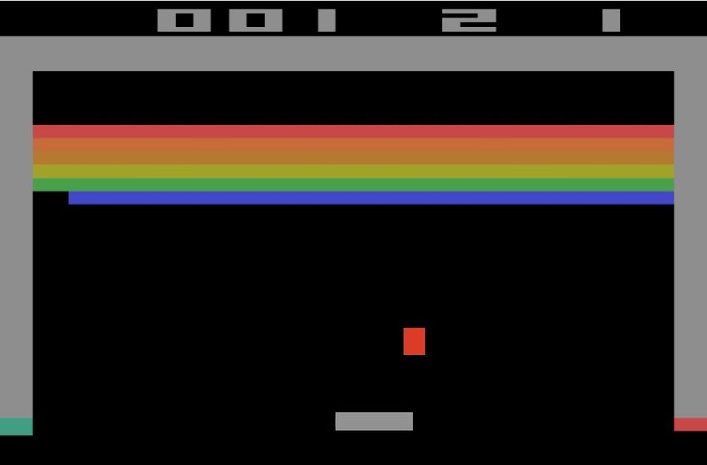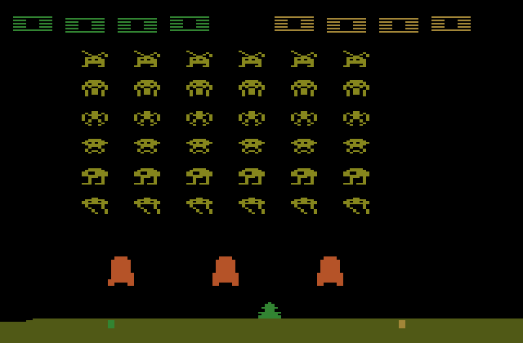The breakdown of whether Artificial Intelligence (AI) could or should be used for Global Conquest is up for debate; there are groups of teams such as DeepMind which have been developing AI that learns to play simple games, such as Space Invaders and Breakout etc.

*Figure 1.*

To do this they use Reinforcement Learning (RL), a teaching technique based on rewards and punishments, to further evaluate if it does something that benefits itself and let it know, so it will keep going in the same direction. If however, it does something wrong it will then influence it to not do something similar again. This along with deep learning is a more proficient approach to estimating environments, which is what makes DeepMind so effective (Mnih, 2018), to the extent that its network can teach itself to play multiple different games at the same time. They call this approach Deep Reinforcement Learning (DRL). This is the approach which was attempted for Global Conquest, as it has shown to be effective for relatively basic games (those that are easy to learn and hard to master, with a good learning curve). “The most successful approaches are trained directly from the raw inputs, using lightweight updates based on stochastic gradient descent.” (Mnih, 2018).

*Figure 2.*

Mnih, is expressing that DRL still uses Deep Learning which has multiple hidden layers for a much more dynamic neural network than a simple neural network illustrated in figure 3, should be trained directly from the raw inputs.

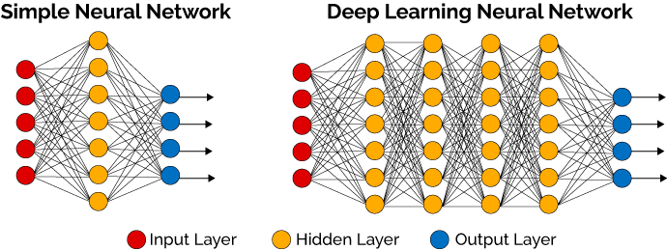

*Figure 3.*

It is stated so strongly here, due to the trustworthiness of Mnih’s work. To be able to feed this network raw inputs, some work may have to be done around the agent even further, as to collect and implement the appropriate type. The reinforcement part of DRL will apply a similar approach to Q-learning in the sense that it will operate with a function value, a more mathematically enforced way of learning with numerical rewards and punishments, attempting to find its way to an end goal. Mnih also states “stochasticity in the dice rolls helps explore the state space and also makes the value function particularly smooth” (Mnih, 2018), a very apt quote that will hopefully reflect on the way it is introduced into Global Conquest, as dice rolls are a big part of the maths behind the game play. The paper written by Minh, previously referred to a few times, is called ‘Playing with Deep Reinforcement Learning’; this paper was very useful when understanding the steps one should take to enable deep reinforcement learning to be implemented. It succinctly depicts the different aspect of DRL, in addition to being a well-structured and clarifying read. The structure introduces the user to a well informed source of information through a well written introduction and background. Later going in depth into the working of DRL, which was the essence of the paper, backed up with experiments which conclude that even though the network isn’t as good as human experts it is better than other networks of similar types and can learn to a proficient standard at a multitude of games. One has to keep in mind potential biases of those who carried out the experiments and wrote the paper though – it is in the best interests of those at DeepMind to have DRL become more trusted as a method. While this is a possible reason for skewed results or opinions which would certainly influence the paper, it is hard to tell whether this is deliberate or not.

# 4.0 Main aims and objectives

1. The creation of the UI (user interface) including replicating the world map.
2. Make a smooth well designed game.
3. All Object-Oriented Programming.
4. Make the agent intelligent, adaptive and competitive.
5. Carry out interviews to get feedback for requirements elicitation.
6. Make Global Conquest a quality product.
7. Train an artificially intelligent agent to play through the use of deep reinforcement learning.
8. Clear documentation through the prototyping methodology during the development process clarifying what was appropriate or not, and why.
9. Carry out test cases throughout development to determine what was successful and what was not, to enable rework as needed and subsequent retest.

These aims and objectives were created to be succinct, brief relatively interrelated and an even mix between what to be achieved and how to achieve it. For instance number 6 (Make Global Conquest a quality product) is a “what to achieve” whereas number 9 (Carry out test cases...) is a “How to”.

# 5.0 Methodology

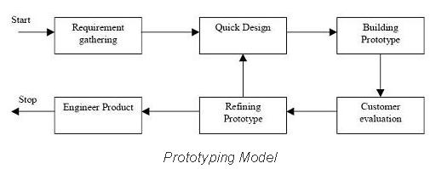The system design for Global Conquest was done through the methodological process called prototyping a very dynamic systems development method (SDM). This follows the (Prototyping Model, 2018) shown in figure 4. Which is known for its faster iterations and for allowing lots of tweaks depending on what the users testing the program suggests along with the opinions of the developer. It is mainly used for creating a quick model to show a possible customer, and was beneficial in this case. Firstly, because of the creativeness of the project changes were not big deals during development of Global Conquest as the next iteration of the model could be shown to users in the next customer evaluation phase. Secondly, because it meant there was less time spent on the development of the games usability and more on how it actually works, this increased the quality of the background code. Another main advantage of this model is that errors are detected earlier and missing functionality is identified more easily, which means a functioning program will be up and running more quickly. A couple of the major disadvantages of this model however are it leads to lots of repairing, which in turn can increase the complexity of the system (Anon, 2018) if not identified and correctly addressed.

*Figure 4.*

The programming language selected for this project was Processing. Processing is a flexible sketchbook for software and a language based on Java for coding within the visual arts context (Processing.org, 2018). It is a simple enough language to get to grips with and with an easy use of visual arts this enabled focus to be on the way the code worked rather than fussing around with all the UI parts, making the game aesthetically pleasing.

Javas simplified syntax and good portability meant there were many opportunities for editing code in any circumstance. When actually programming Global Conquest a breakdown of all the possible objects was a strong and decisive start point. It clearly identified the areas of code for encapsulating the objects of Territory, User and Agent (Fig 5.) a heavy debate was whether Troop should be an object as well. 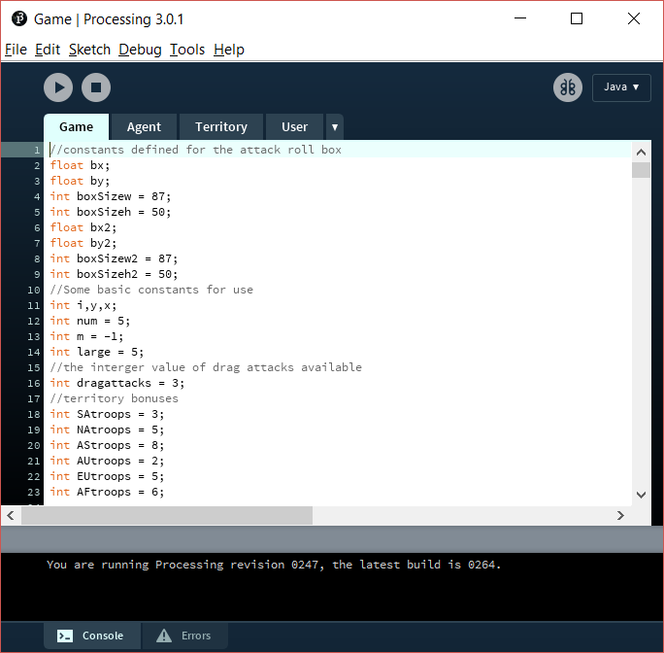

*Figure 5.*

## 5.1 Requirements Elicitation

The purpose of requirements elicitation is to identify the risks, needs and assumptions associated (Masters, 2018). Gathering requirements over the years has differed massively in terms of game design, with the use of user testing and over the years this has become a group collaboration between the stakeholders, developers and users (Fidas, 2018). Originally the requirements for Global Conquest were gathered through the use of brainstorming, prototyping and interviews - three well known techniques that are more business based but which were tailored to the context of the game. Brainstorming was done throughout development, and was a constant point of referral but as there was only one developer he brainstormed with the project supervisor (James Borg) rather than other co-developers. Initially they met weekly sharing thoughts and getting another point of view to feed off, then when the games approach was more established the meetings moved out to fortnightly. Prototyping allows a much better understanding of the end product as the visual representation can be provided from paper examples to interactive gameplay, with game play tested using test cases which is an effective method of systematically testing a system to make sure it is functioning to its true potential. After each iteration of the prototype, the requirements would evolve slightly based on the stakeholders input and from input gathered during interviewing. Finally, but not least important, were the interviews on outsiders opinions of the game which produced a lot of great feedback on whether it was adequate along with possible requirements that hadn’t previously been considered – it is a really effective requirements elicitation technique.

### 5.1.1 Functional Requirements

* Allow user to assign troops
* Allow user to roll dice
* Allow user to attack internally or externally
* Allow agent to assign troops
* Allow agent to roll dice
* Allow agent to attack internally or externally
* Agent heuristics so there are easy/medium/hard modes
* Artificially intelligent agent to play against
* Assign Territory bonuses
* Enforce maximum troop capacities
* Calculate a win or a loss

### 5.1.2 Non-Functional Requirements

* Computer good enough to run processing (correct platform)
* Mouse/track pad
* Frame Rate
* Required resources
* To be Secure

## 5.2 First Prototype

### 5.2.1 Quick Design

This was the first iteration of the prototyping methodology however, the requirement gathering for the beginning of the prototyping method shown in figure 4 was the requirements elicitation. The quick design stage in this instance was in fact the attempted implementation of new requirements to try and complete in the following prototype. The ones chosen in the first iteration were mainly to create a UI of the world map, while following object-oriented programming (OOP) techniques.

### 5.2.2 Building Prototype

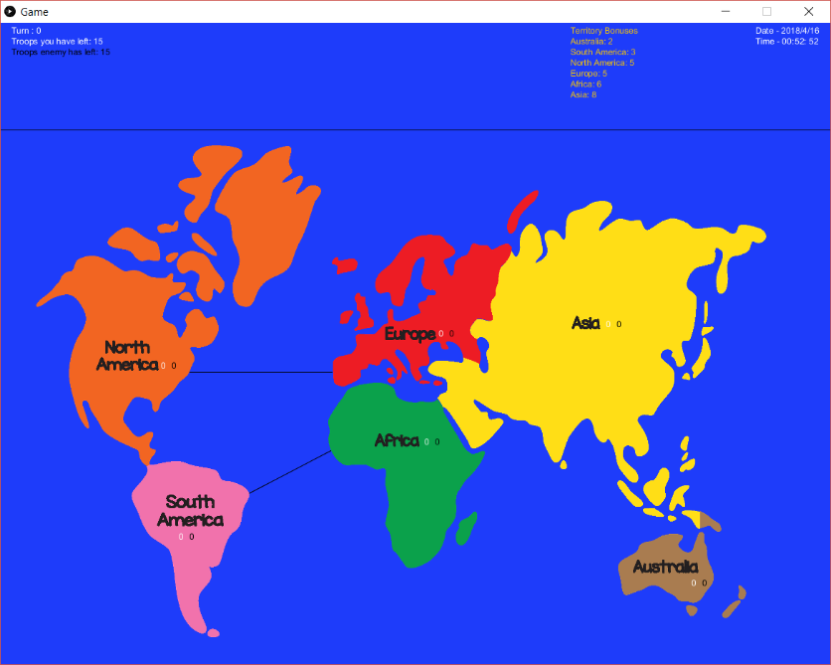After the three objects were set in stone, a basic enough UI was next on the agenda as that would enable users to reveal if the implementation was functioning correctly. This was accomplished by breaking down an image of a world map (World Map – Continents, 2018) combined with the use of paint.net (image editing software) which allowed the cropping of all individual continents into separate images with a translucent background. This enabled the creation of the map figure 6.

*Figure 6.*

A prolonged period of time was spent trying to get Processing to listen to detect when the mouse was over each image, however this proved problematic and there was no way for the listening to be implemented. Instead boxes defined in Processing as a 2D primitive allowed boxes to be created under the images which could then be individually listened to by the program (Figure 7.) found in appendix B.

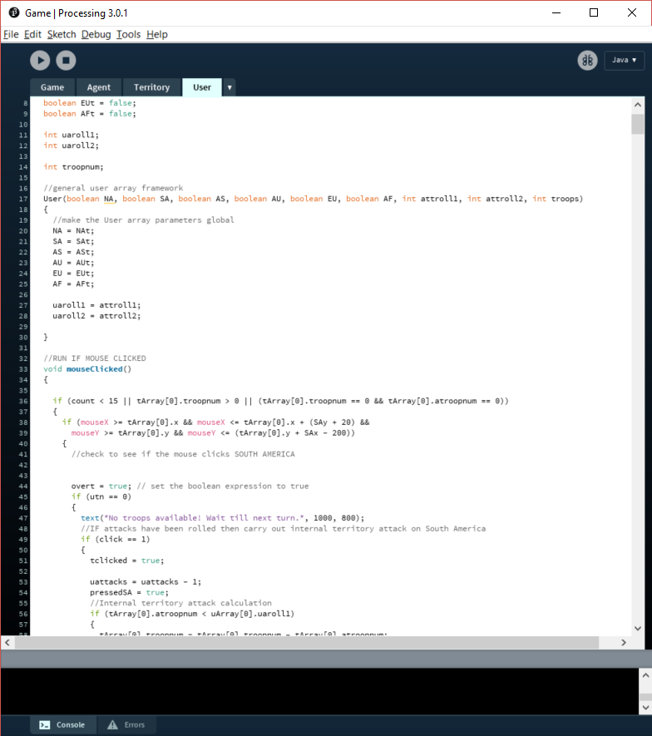

*Figure 7.*

Once these had been correctly positioned this meant that the territories had a way of being interacted with, a primary concept of Global Conquest. After this interactive map had been made available, the actual programming and maths behind the game had to be completed. The draw method in Processing acts as a constant for loop updating the UI which is advantageous because of the listening that is constantly occurring for events. An event processing language, allows a dynamic reaction to things such as mouse clicks, key presses or any interactions.

### 5.2.3 Customer Evaluation

For the first iteration of the model, as it was too preliminary to get any users involved the project supervisor (James Borg) carried out the evaluation. He gave his opinions on the map/UI as well as his approval of the original system design, so the developer moved on to refining the prototype which was to determine what step requirements were next to be implemented.

## 5.3 Second Prototype

### 5.3.1 Quick Design

The next interactions were how the user plays, clicking on territories to allocate troops, rolling attack, troop reserves and attacking enemy troops internally or externally. For more detail into how these moves work and general gameplay, please see appendix A - User Guide. Actions such as these could only be implemented once the program had been split up into all the separate objects needed, as these interactions had to occur in an encapsulated, reusable manner a good practice when programming the basics of object-oriented programming (OOP). The only negative is that when trying to implement OOP a class had to be created to allow for functions to be implemented between that and the main running code. These classes had to be developed so that the ‘objects’((Stefik, 2018) defines objects as “entities that combine the properties of procedures and data since they perform computations and save local state”) could be uncomplicated and have attributes that are very easily called upon/sent messages such as new troop numbers.

Traversing back to the actions the object defined user will be making, attacking internal/external and troop allocation. This was made easier by the OOP mainly because it was more straightforward to put the code into the correct areas and have reactions based on events, such as clicking a territory, as everything was modularised.

### 5.3.2 Building Prototype

Once a click had occurred on a specific territory, for example Africa, and depending on the state of the game being either in the attack phase or allocation (flagged by simple boolean variables) the attack calculation would take place or, a simple allocation would occur (Figure 8 for a deeper understanding of this figure please see appendix B). This would in turn send a message to the territory array object ‘Africa’ and update its troop numbers and/or ownership depending on whether the event had left it without agent troop numbers.

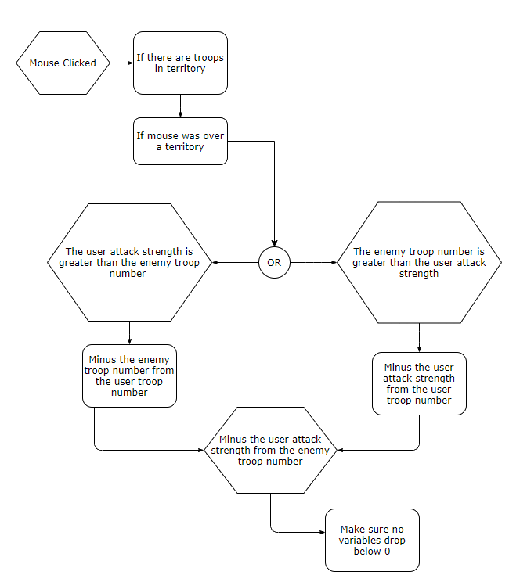

*Figure 8.*

A second action is external attacks, these are caused by dragging the mouse from one territory to another, to attack if the enemy has troops in the territory or to transfer forces to a territory already owned. Similar is the internal attacks implementation, where the system listens for a release of the mouse over a territory and checks to see if it was pressed down over a connecting territory e.g. Australia/Asia this is shown in figure 9.

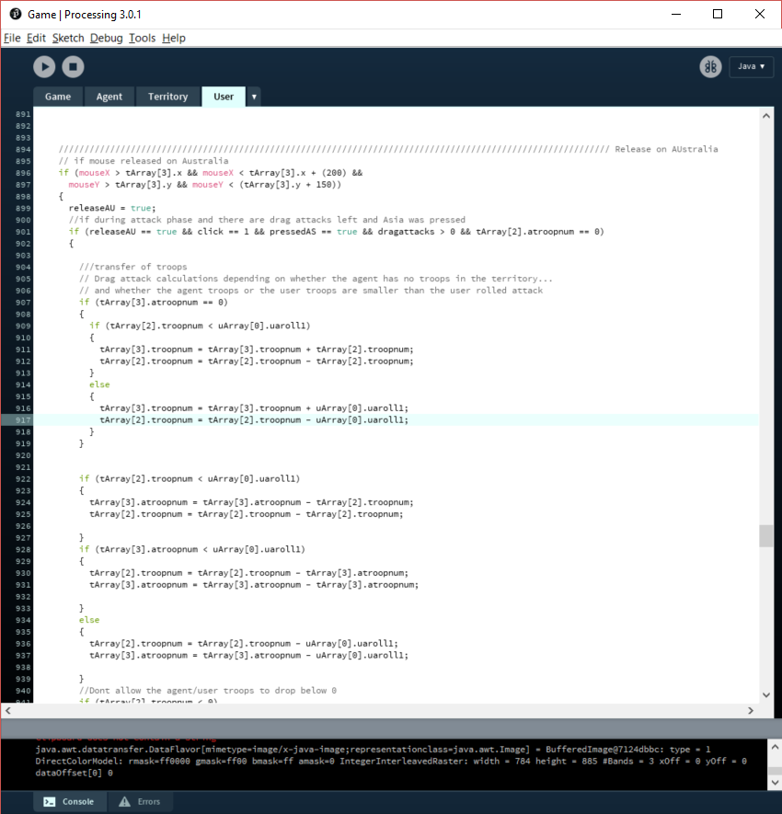

*Figure 9.*

If this occurs then the system does the maths behind the attack or the transfer. For an attack from Asia to Australia, the system calculates agent troops in Australia minus the attack strength of the user. For a transfer, the system subtracts the attack strength from the user troops in Asia and adds them to the user troops in Australia. Also, the system will not allow either an attack or a transfer that would drop anything below 0 as you cannot have negative troops.

### 5.3.3 Customer Evaluation

During this second prototype iteration test cases were introduced as the approach to customer evaluation, which was achieved by the developer carrying out a systematic comb through of the code, testing all he could and documenting what failed its tests. The failures helped the developer identify opportunities to refine the code and also the need for some new code to address unrealised requirements.

## 5.4 Third Prototype

### 5.4.1 Quick Design

A realisation that there would need to be rewards for owning a territory. It was determined its value should depend on the combination of two factors – the size of a territory combined with the number of connections the territory has to other territories. A second realisation made during initial testing of this troop bonus was that the troop numbers in some territories went- into the hundreds in only 5-6 turns. This was not acceptable as it would make this wall of troops impenetrable to an opponent whose maximum attack strength was limited to 6 by the rules.

### 5.4.2 Building Prototype

|  |  |
| --- | --- |
| **Territory** | **Bonus** |
| South America | 3 |
| North America | 5 |
| Asia | 8 |
| Australia | 2 |
| Europe | 5 |
| Africa | 6 |

To address the above realisations, the need for a reward led to a ‘troop bonus’ and a maximum troop capacity (Figures 10 & 11. for the source code behind the implementation of these view appendix B, 9.2.2 and 9.2.3) were added to the object Territory to constrain numbers of troops per territory thereby making winning or losing realistically achievable, provided the dice rolls are lucky enough.

|  |  |
| --- | --- |
| **Territory** | **Capacity** |
| South America | 30 |
| North America | 35 |
| Asia | 50 |
| Australia | 20 |
| Europe | 30 |
| Africa | 35 |

*Figure 11.*

*Figure 10.*

Another one of the objects in question for Global Conquest is the agent that is acting as the enemy. The aim for this agent was for it to be able to make logical decisions to help it towards winning. When programming this a great deal of thought had to go into data acquisition for the use of decision making. A few different formats of data were used; Booleans, Arrays, Integer Lists etc. However a starting point was to make the agent randomly use the data for attacks, which meant having to effectively implement the random pre-defined function along with the Booleans used for flagging when a territory was owned. To find out where the agent is to attack, an integer list needed to store the non-owned territories to randomly choose from, just for troop allocation the code for which is shown in figure 12. A complicated but necessary route of action.

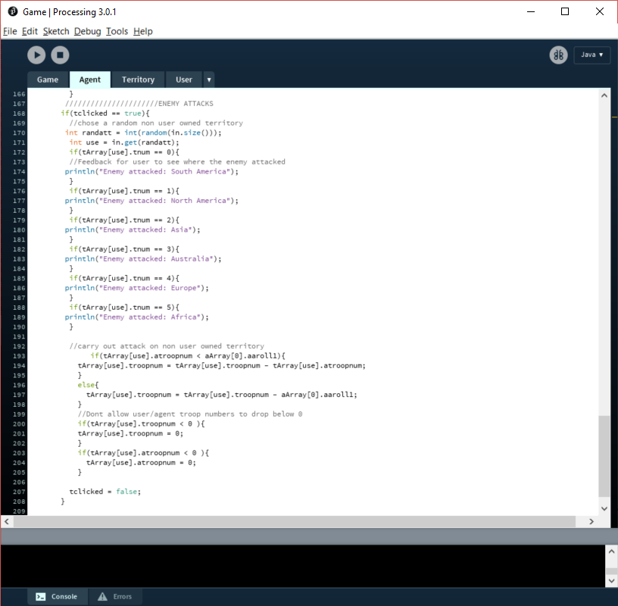

*Figure 12.*

Once this agent was created and could randomly attack, the data it was being handed had to be used intelligently to inhibit the ‘logical’ decisions that it had to make. An agent in itself is situated in an environment and is capable of autonomous action in order to meet its objectives (Agent Technology, 2018). There was a long list of rules that were implemented in the agent object, a large proportion of which ended up using very random ways of attacking and allocating. However, this would be easily developed in the future. To make the task of enabling the agent to make logical decisions a need to provide it with an end goal, or goals to aim for became apparent. This in theory was possible with the use of some variables such as territory capacity and troop bonuses as goals. They would have to be put on a scale of benefits and the agent would have to make its decisions based on how large the benefit is, which in theory is relatively simple but in practice less so.

### 5.4.3 Customer Evaluation

The customer evaluation for the third prototype was a post-game interview, made to gather information about whether users liked or disliked different aspects about the game and background information to see if they usually enjoyed games of this nature. Targeting possible users in a range of 18-21 year old university students is a strong way of finding a wide range of opinions, ideas and out of the box possibilities. This led to refining the prototype to a point of uncertainty over whether development should aim towards an intelligent agent or train an artificial intelligence to act as the enemy.

6.0 Results

## 6.1 Test Cases – Unit Testing

These test cases test many of the technical aspects of Global Conquest code. Each test case has its own test case ID which have been split up into general test cases (TC00), user test cases (UTC00), agent test cases (ATC00) and territory test cases (TTC00). When creating figure 13 the code was systematically combed through testing at all the major implementations, which turned out to be mostly requirements or aims and objectives.

|  |  |  |  |  |
| --- | --- | --- | --- | --- |
| **Test Case ID** | **Test Scenario** | **Test Steps**  *Figure 13.* | **Expected Results** | **Actual Results** |
| TC01 | Check Initial user Troop allocation Works | 1.Click on South America  2. Click on North America  3. Click on Asia  4. Click on Europe  5. Click on Australia  6. Click on Africa | 1 troop allocated to user troop number in each territory | 1 troop allocated to user troop number in each territory.  **Pass** |
| TC02 | Check Initial agent Troop allocation Works | 1.Allocate all initial agent troops | 15 randomly allocated agent troops | 15 randomly allocated agent troops  **Pass** |
| TC03 | Check roll attack box appears when user troop reserve hits 0 | 1.Allocate troops until user troop reserve hits 0 | Roll attack box appears | Roll attack box appears  **Pass** |
| TC04 | Mouse hover over roll attack box changes the tint of the box | 1.Allocate troops until roll attack box appears  2. Move mouse over the roll attack box | The box colour gets darker | The box colour gets darker  **Pass** |
| TC05 | Once the roll attack box has been clicked randomly roll attack strengths and troop reserves for next turn (USER). | 1.Allocate troops until roll attack box appears  2. Move mouse over the roll attack box  3.Click the roll attack box | User Attack Strength = 1-6  User Troop Reserve = 1-12 | User Attack Strength = 1 User Troop Reserve = 2  **Pass** |
| TC06 | Once the roll attack box has been clicked randomly roll attack strengths and troop reserves for next turn (USER). | 1.Allocate troops until roll attack box appears  2. Move mouse over the roll attack box  3.Click the roll attack box | User Troop Reserve = 6-12 | User Troop Reserve = 8  **Pass** |
| TC07 | Once the roll attack box has been clicked randomly roll attack strengths and troop reserves for next turn (AGENT). | 1.Allocate troops until roll attack box appears  2. Move mouse over the roll attack box  3.Click the roll attack box | Agent Attack Strength = 1-6  Agent Troop Reserve = 1-12 | User Attack Strength = 3 User Troop Reserve = 10  **Pass** |
| TC08 | Once the second internal territory attack has been used, end attack phase and update troops (USER) | 1.Allocate troops until roll attack box appears  2.click the roll attack box  3. click on territory with user troops twice | The user troops to be allocated next turn becomes the new troop reserve | The user troops to be allocated next turn becomes the new troop reserve  **Pass** |
| TC09 | Once the second internal territory attack has been used, end attack phase and update troops (AGENT) | 1.Allocate troops until roll attack box appears  2.click the roll attack box  3. click on territory with user troops twice | The agent troops to be allocated next turn becomes the new troop reserve | The agent troops to be allocated next turn becomes the new troop reserve  **Pass** |
| TC10 | Test the enter button can only be pressed once the attacks have been rolled | 1.Allocate troops until roll attack box appears  2.click the roll attack box  3. click on territory with user troops twice  4.Allocate all of the user troops  5.Press Enter | Nothing happens update troops | Nothing happens  **Pass** |
| TC11 | Test the enter button can skip the attacks | 1.Allocate troops until roll attack box appears  2.click the roll attack box  3. click on territory with user troops twice  4.Allocate all of the user troops  5.Roll attacks  6.Press Enter | Troop reserves Update and attack phase ends | Troop reserves Update and attack phase ends  **Pass** |
| TC12 | You win! Appears when the user owns all the territories | 1.Allocate troops until roll attack box appears  2.click the roll attack box  3.Use drag attacks tactfully  4.click on territory with user troops twice  5.Allocate all of the user troops  6.Roll attacks  7.Repeat until win | You Win! Appeared | You Win!  Appeared  **Pass** |
| TC13 | All the territory bonuses are added (USER) | 1.Allocate troops until roll attack box appears  2.click the roll attack box  3. click on territory with user troops twice | Territories owned by user increase by correct territory bonus | Territories owned by user increase by correct territory bonus  **Pass** |
| TC14 | All the territory bonuses are added (AGENT) | 1.Allocate troops until roll attack box appears  2.click the roll attack box  3. click on territory with user troops twice | Territories owned by agent increase by correct territory bonus | Territories owned by agent increase by correct territory bonus  **Pass** |
| TC15 | The Agent Can Win | 1.Allocate troops to Australia until roll attack box appears  2.click the roll attack box  3.Skip attack phase  4.Allocate all of the user troops to Australia  5.Repeat until Agent Wins | You Lose! appears | The game didn’t end  **Fail** |
| UTC01 | Internal territory attack, click on a territory with both user troops and agent troops in it | 1.Allocate troops until roll attack box appears  2.click the roll attack box  3. click on territory with both user troops and agent troops present | Took away the user attack strength from both user troops and agent | Took away the user attack strength from both user troops and agent  **Pass** |
| UTC02 | Internal territory attack, click on a territory with both user troops and agent troops in it | 1.Allocate troops until roll attack box appears  2.click the roll attack box  3. click on territory with both user troops and agent troops present, but where agent troops < user attack strength | Took away the user attack strength from both user troops and agent but didn’t go below 0 | Took away the user attack strength from both user troops and agent but didn’t go below 0  **Pass** |
| UTC03 | Check updated user Troop allocation Works | 1.Allocate troops until roll attack box appears  2.click the roll attack box  3. click on territory with user troops twice  4.Click on all territories with user troops present | 1 troop is added to each of the territories with user troops present | 1 troop is added to each of the territories with user troops present  **Pass** |
| UTC04 | Agent randomly clears out user troops | 1.Allocate troops until roll attack box appears  2.click the roll attack box  3. Drag from a user owned territory  4.Look for a random territory with user troops present to lose the agent attack strength in troops | Random territory with user troops present reduces by the same as the agent attack strength | A normal drag attack occurs, nothing seems to change  **fail** |
| ATC01 | Check updated agent Troop allocation Works, where it can only allocate to territories with agent troops in | 1.Allocate troops until roll attack box appears  2.click the roll attack box  3. click on territory with user troops twice  4.Use all of the user troops | A random troop is added to territories with agent troops present | A random troop is added to territories with agent troops present  **Pass** |
| ATC02 | Test the agent can allocate troops without a user input once the user has run out | 1.Allocate troops until roll attack box appears  2.click the roll attack box  3. click on territory with user troops twice  4.Use all of the user troops | The remaining agent troops are randomly allocated to territories with agent troops present | The remaining agent troops are randomly allocated to territories with agent troops present  **Pass** |
| TTC01 | The Territory maximums work | 1. Use all troop allocations possible, after each turn.  3.Repeat until all territories are stuck at maximums troop capacity(either user or agent) | All territories stuck at maximums | All territories stuck at maximums  **Pass** |

## 6.2 User Testing Interviews

This is an example of the interview, relatively short but allows the person being interviewed to give the information required to find new requirements. The vagueness in some of the questions makes the person in this case Sam Longstaff to think outside the box and realise that a connection between Asia and North America might make for a more interesting competition for the territory. As shown in figure 14. These were used more for refining the prototype rather than testing the system.

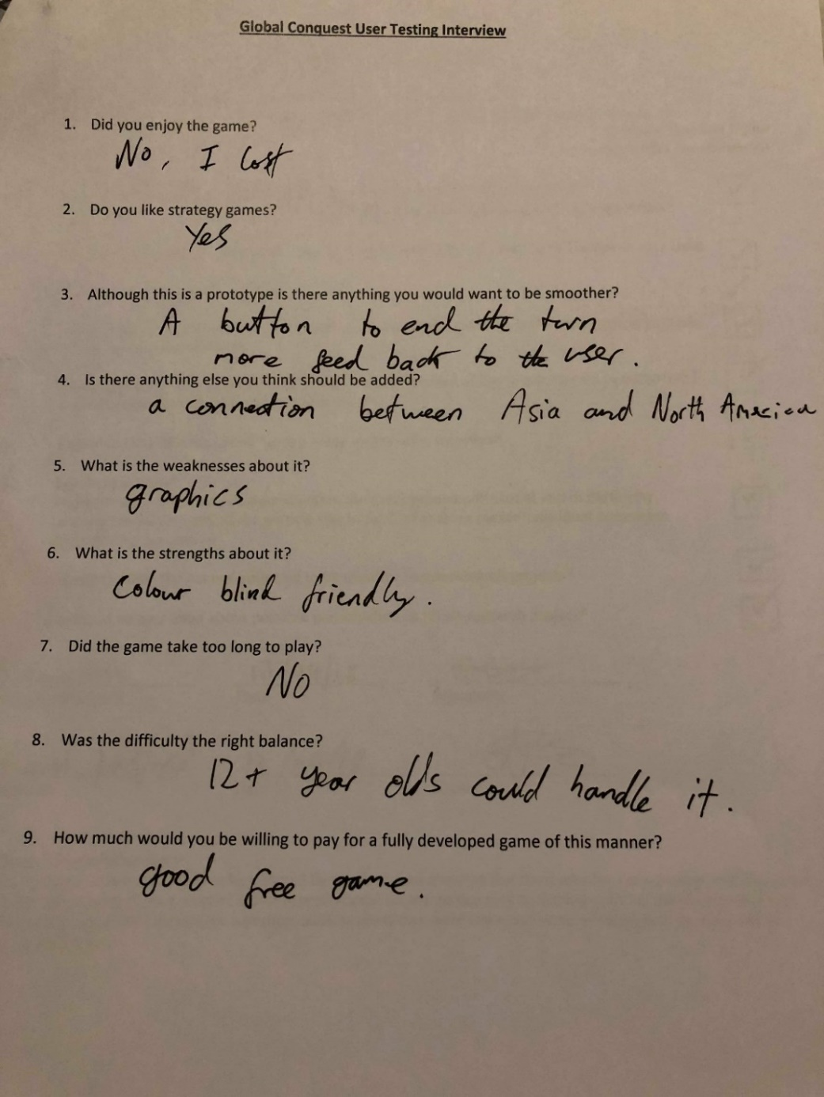

*Figure 14.*

There were lots of interesting points raised in the interviewing process, below are the ones which will positively contribute to the refining of the prototype. Especially as in figure 14, the tester lost the game which made him think about what could have helped him win, being a connection between Asia and North America. The strong competitive nature of problem solving is what kept the user interested, competitive problem solving is the primary way humans train themselves to think. (Burgen, 2013)

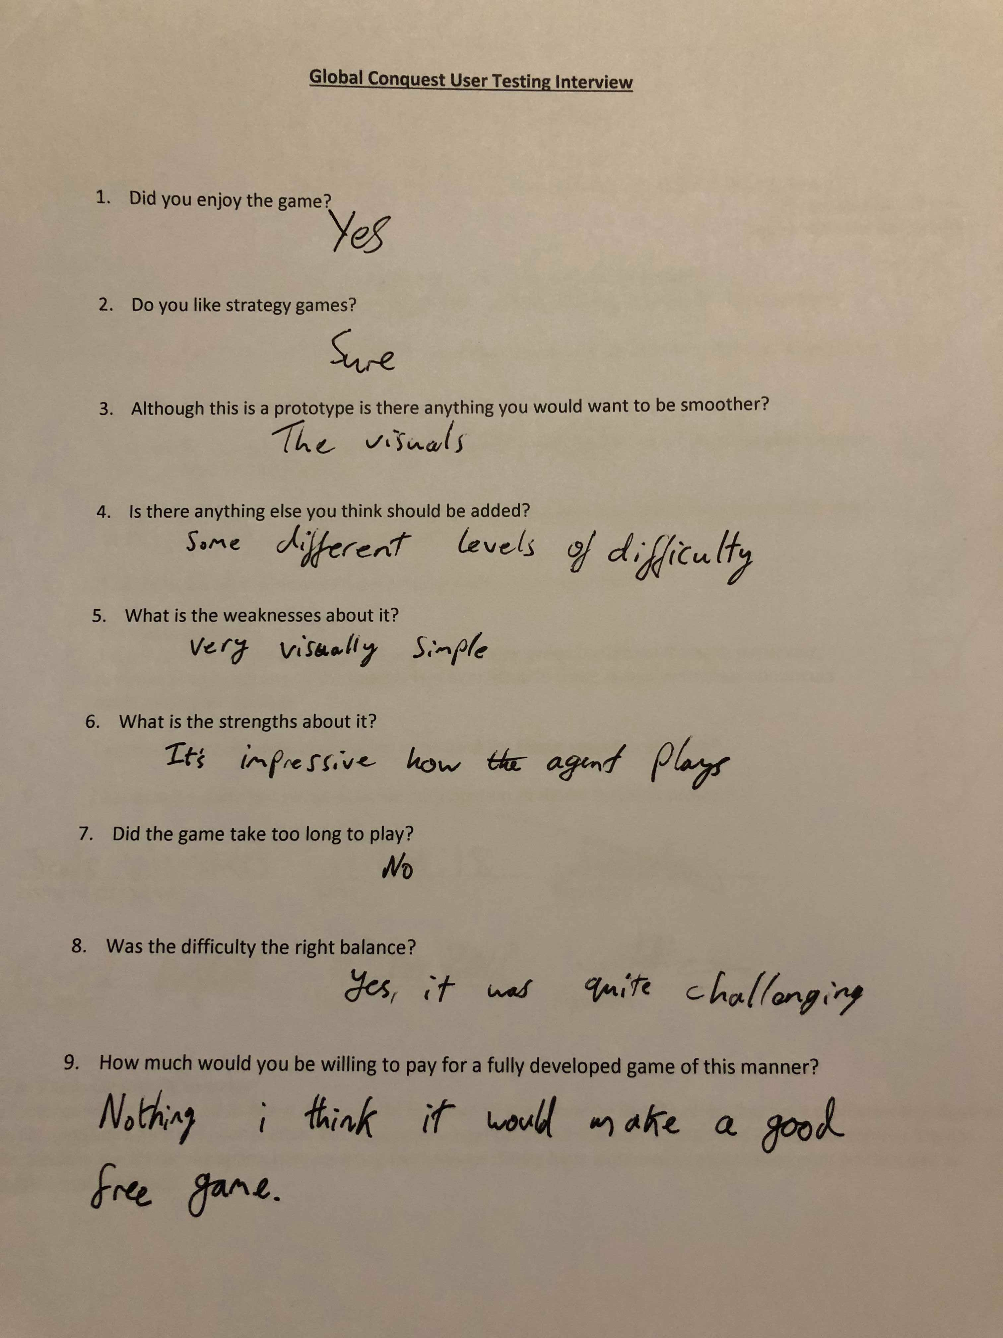

*Figure 15.*

Figure 15 is useful because it allows for gameplay at many different skill levels. 85% of people who contributed to a poll on gamespot agreed, this population group for a poll will be people who also enjoy games. Making then input much more topical. (Anon, 2018).

*Figure 16.*

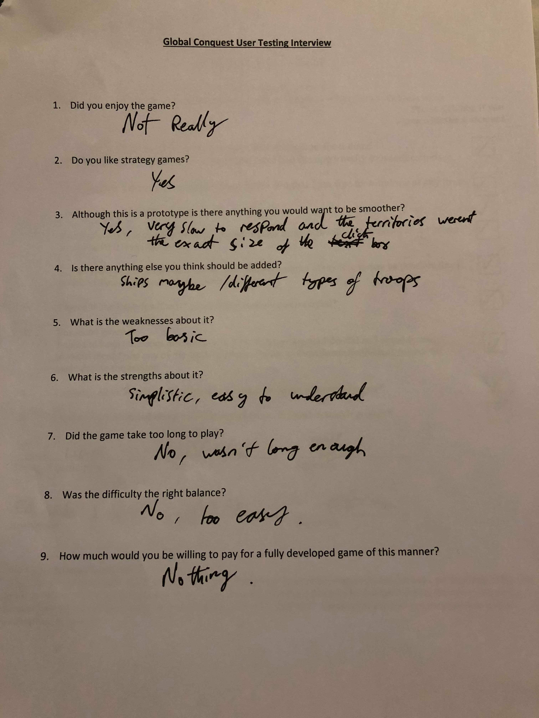

Figure 16 is interesting as a possible idea for making the game attacks more diverse a certain way of keep the player more engrossed.

*Figure 17.*

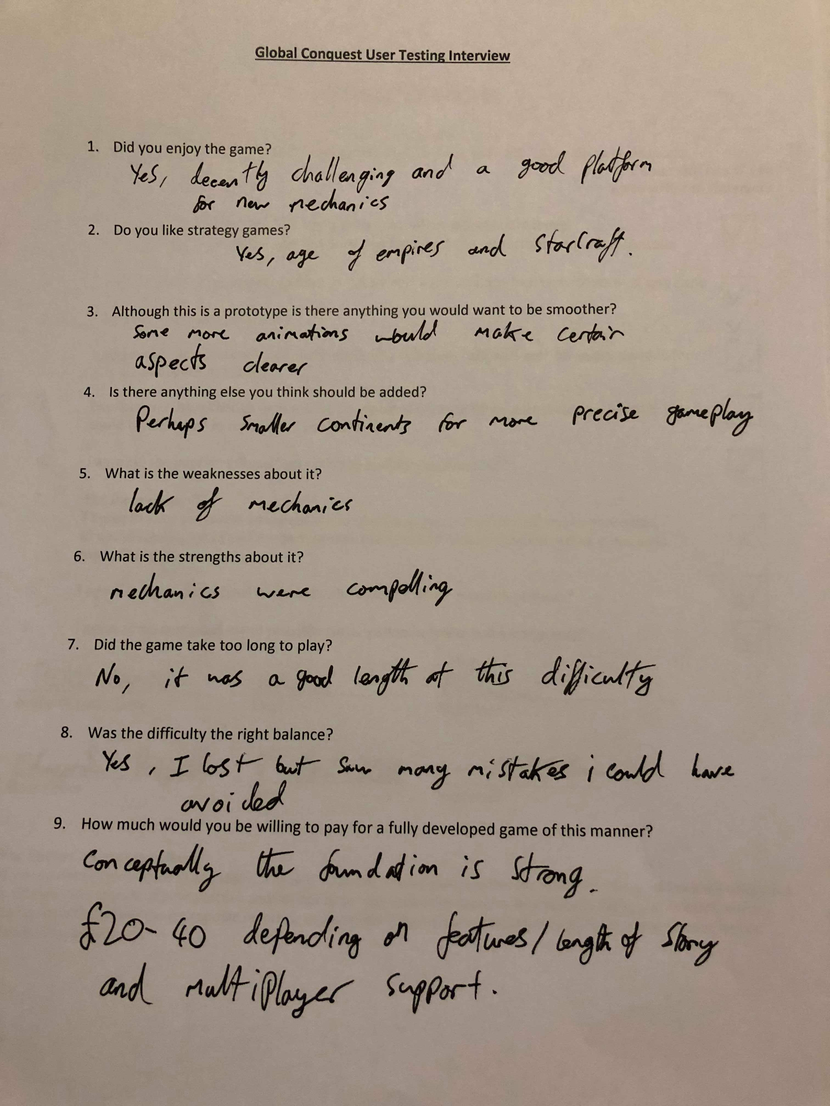

The end of this interview shown in figure 17 was informative, it let the developer know that even though the agent was random at this point it 30 turns was a good game length, and the randomness wasn’t good enough because the second time round the user would of avoided the mistakes made. Along with a compliment in quesiton 9, stating their opinion that the concept is strong.

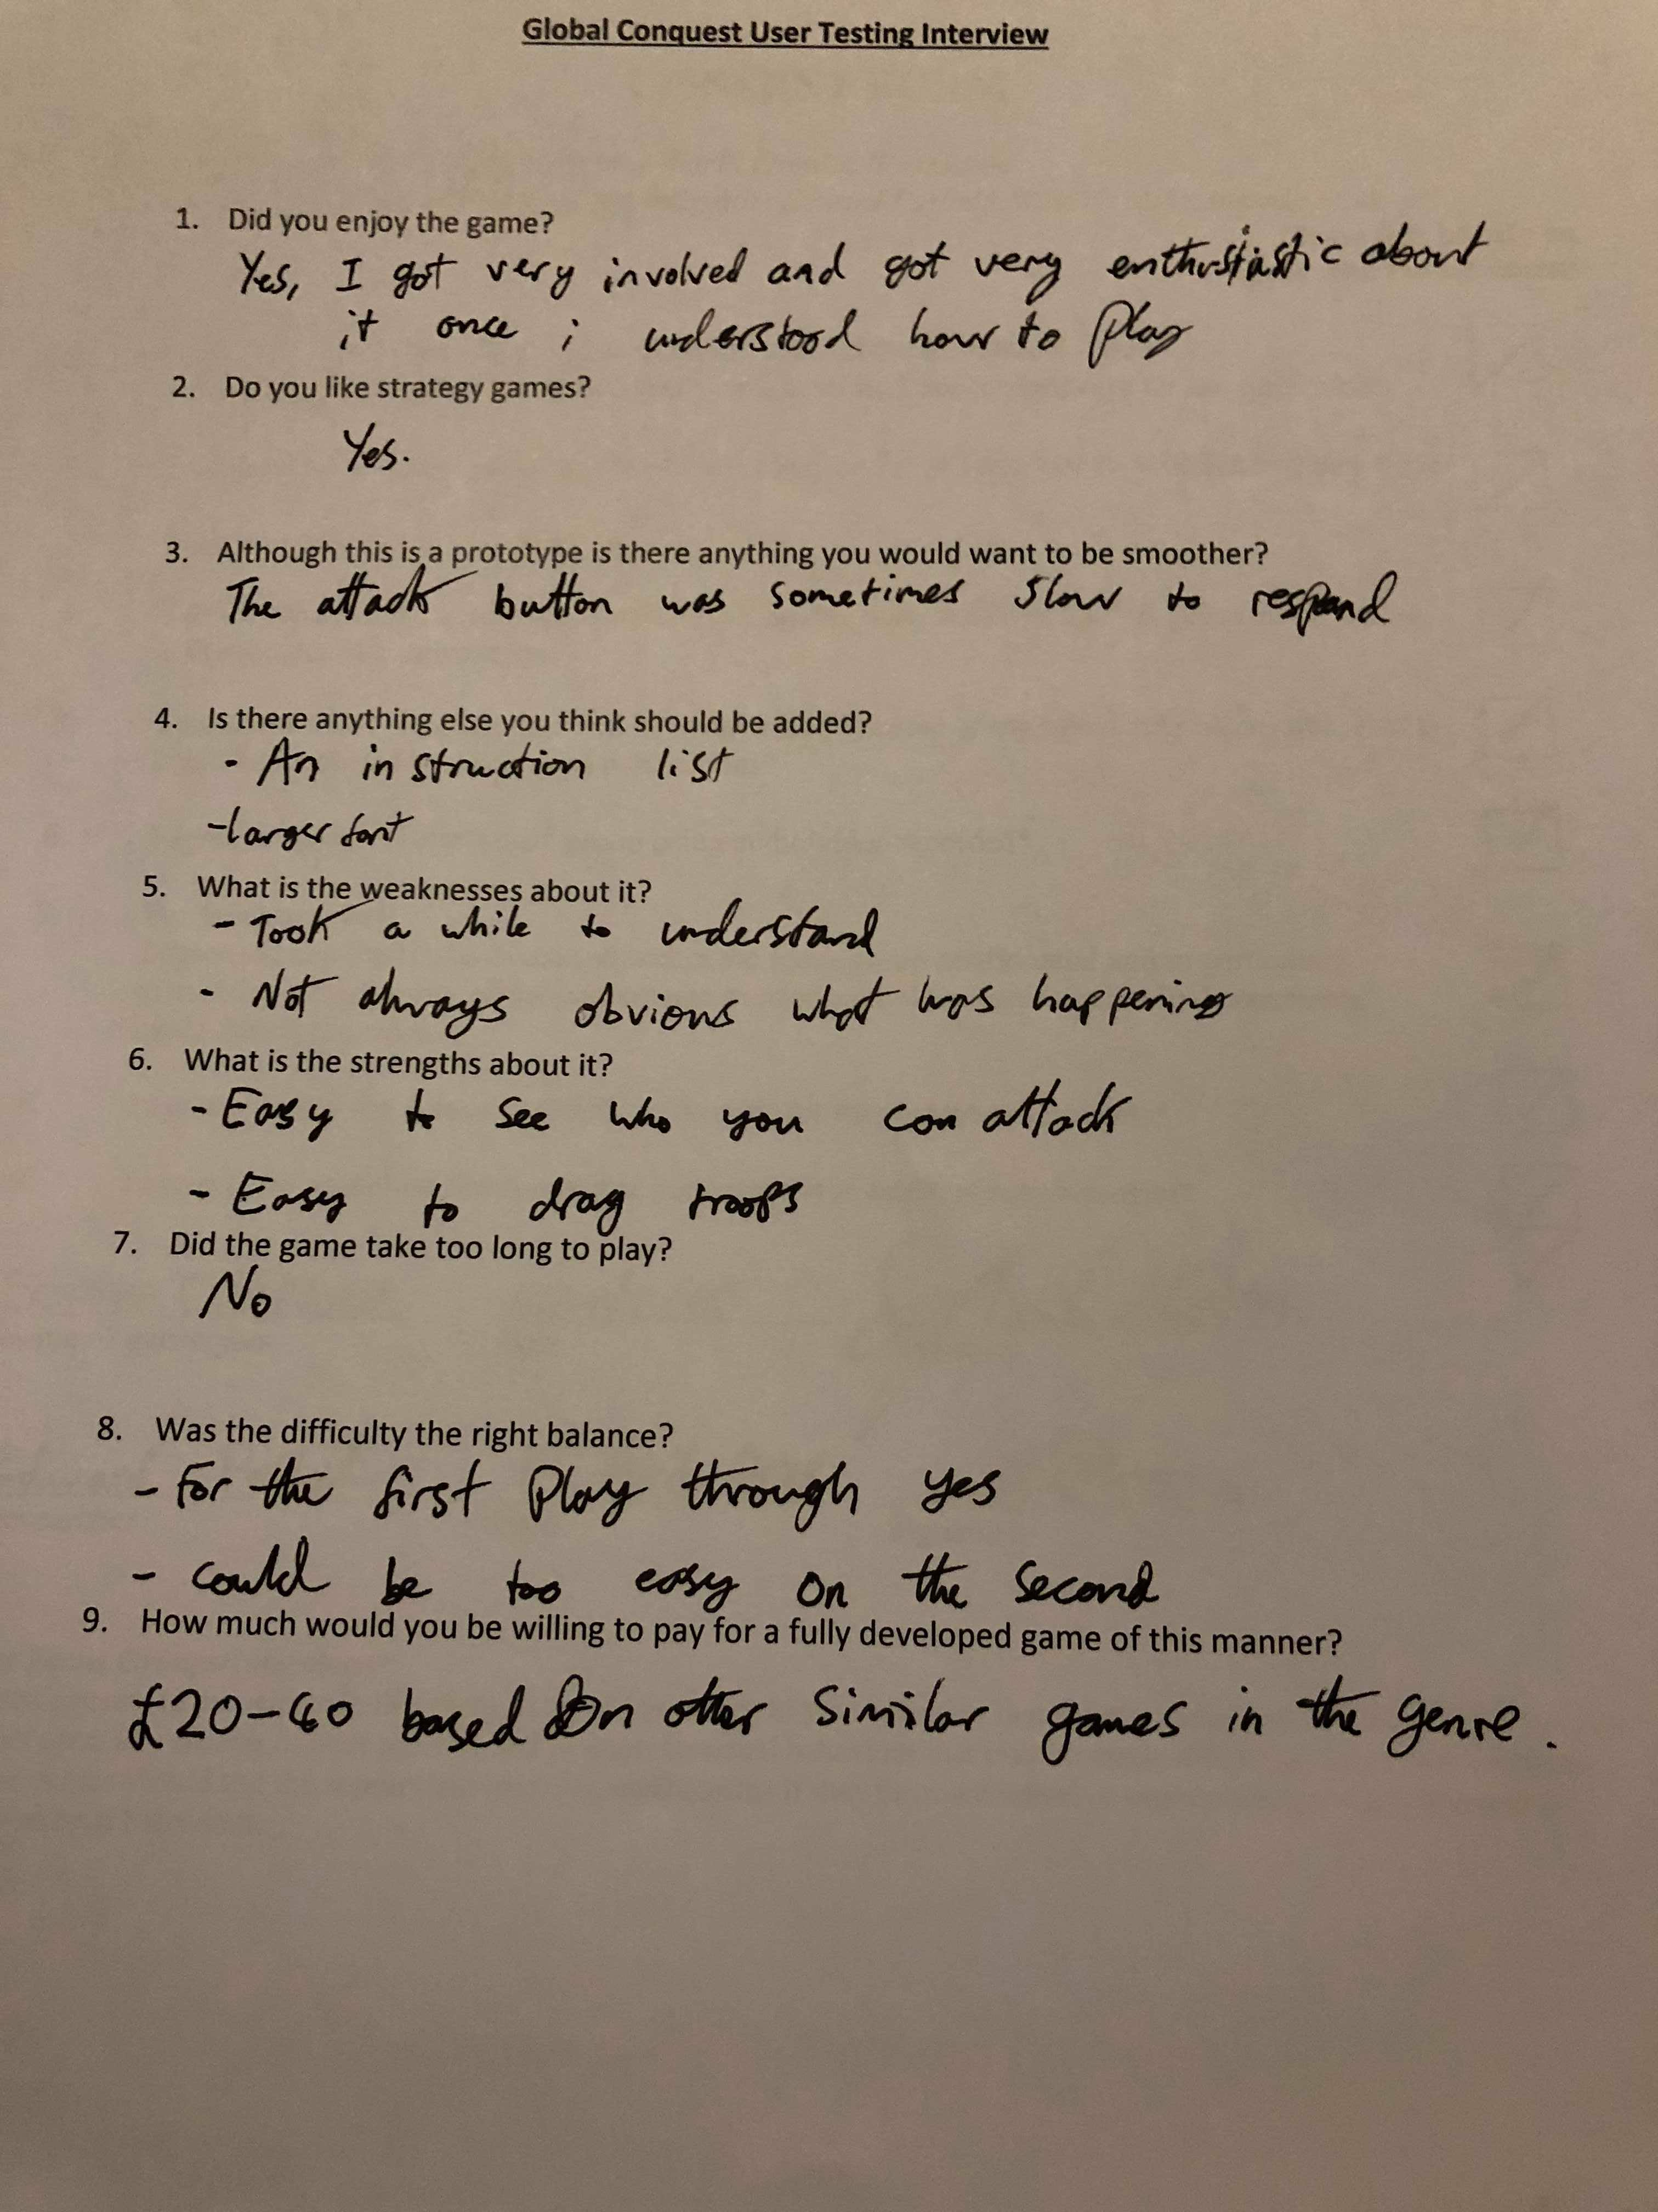

*Figure 18.*

Figure 18 and Figure 19 agree that some sort of move prompt/rules would be complementary to have on screen the help the usablility.

*Figure 19.*

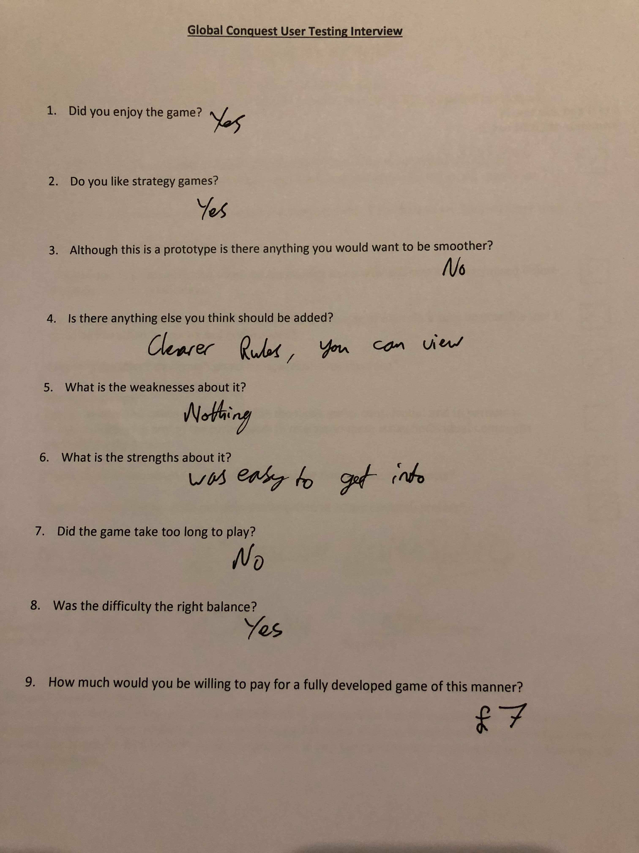

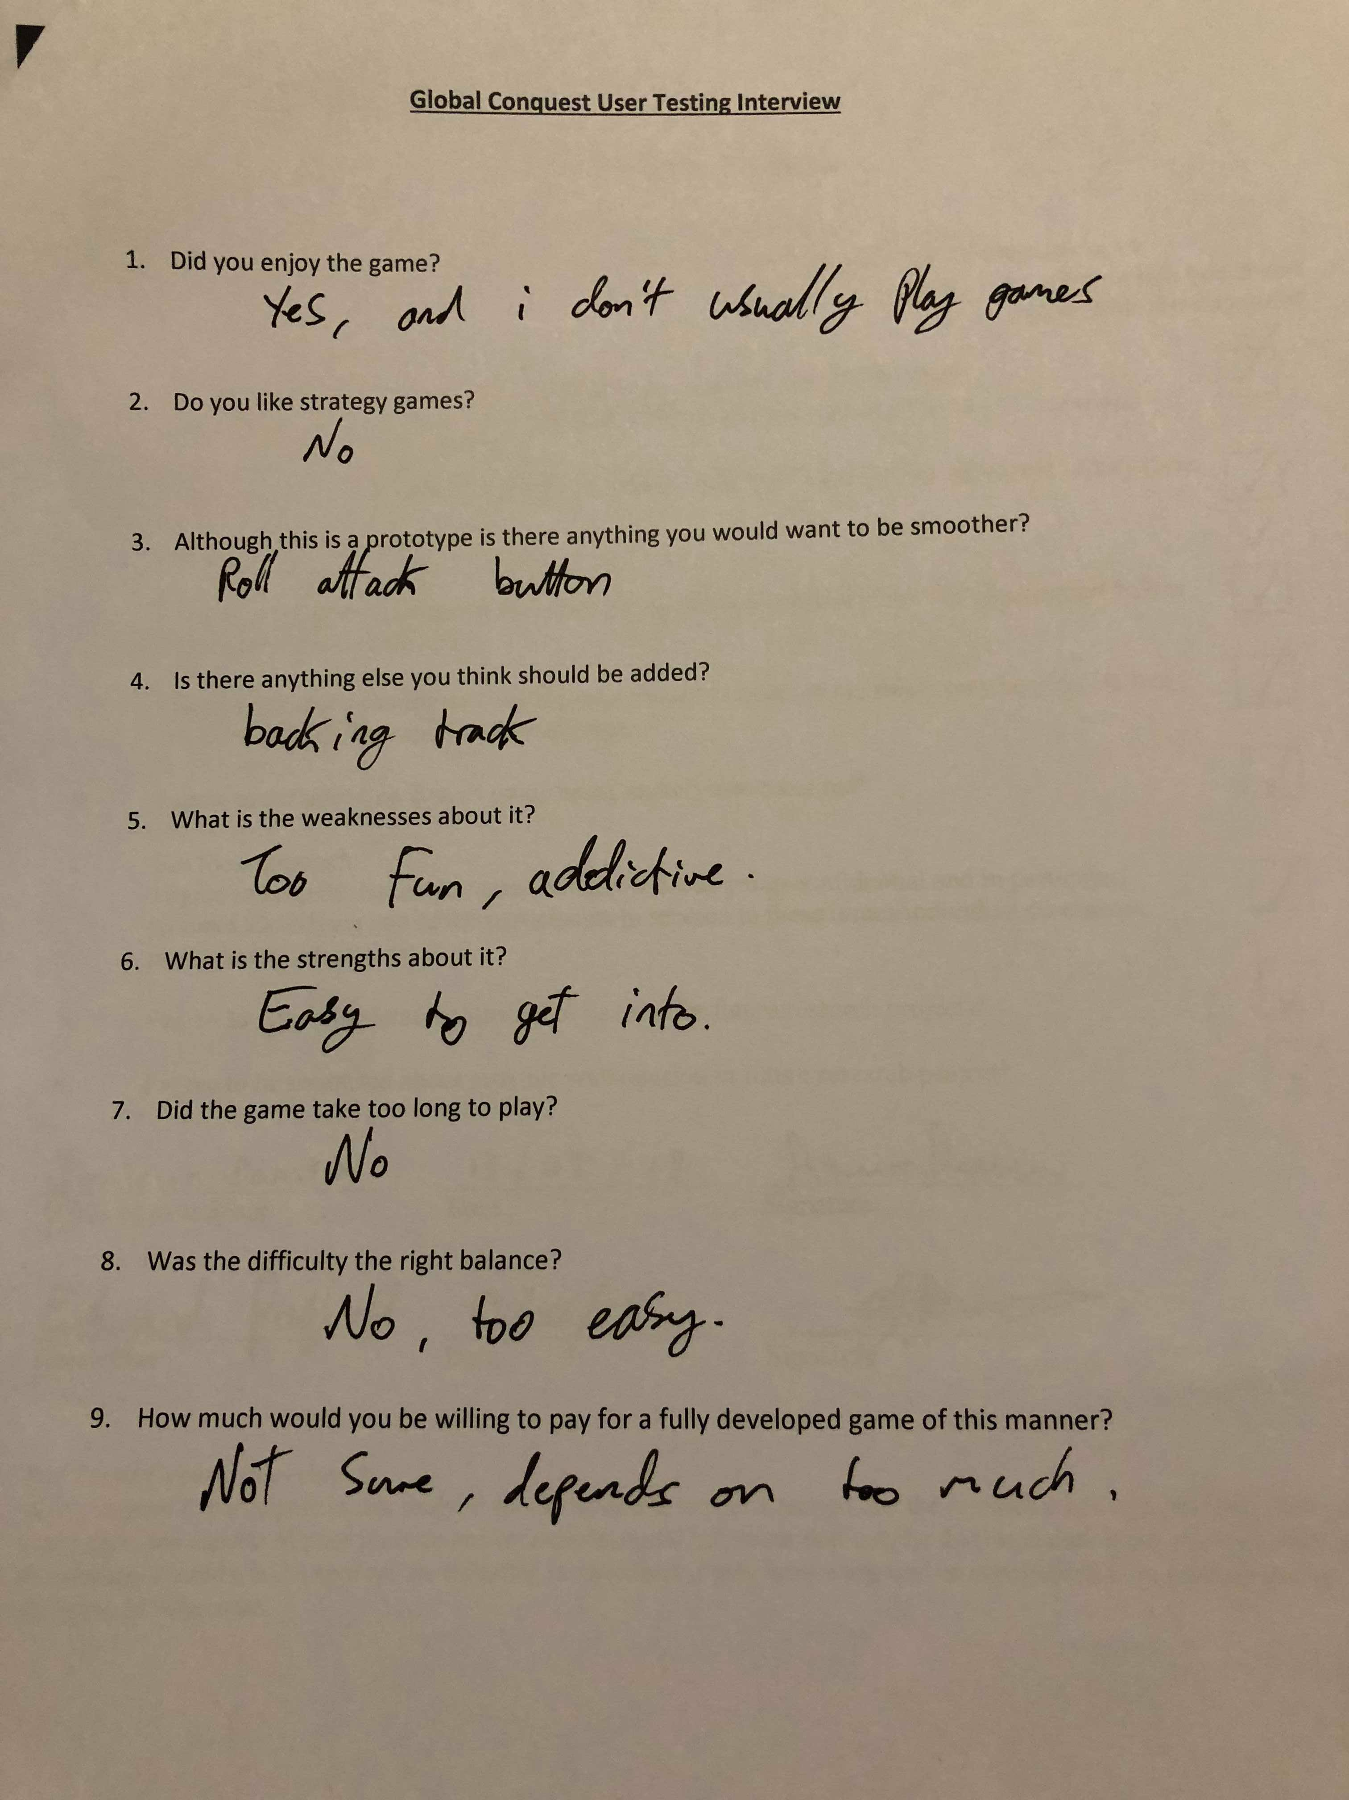

*Figure 20.*

Figure 20 gives a great feedback about audio, a backing track this could consist of sound clips for when you attack or end a phase, little hints to help usability. Also the roll attack button is sometimes slow this was a limitation of Processing as nothing would make it more responsive.

## 6.4 Product Evaluation

Global Conquest meets all but two of the initial requirements. Firstly, having agent heuristics so there are easy/medium/hard modes which figure 15 proves. Secondly, having an artificial intelligent agent to play against. The testing all of the technical aspect systematically and then getting opinions from possible users which agreed with the statement that almost all of the initial requirements were met through interviews. The requirements that were met are about simplistic gameplay, getting the prototype up and running. A task which in general has been completed as user/agent attacks and allocations work, there are limits, rewards and a win or a loss is calculated. The interviews were really useful when evaluating the product it gave an outside opinion on the whole system.

## 6.5 Introspection

One of the few mistakes made during the development process of Global Conquest was the implementation of agent attacks, system states should have been developed from earlier on to allow for an agent to base its attack depending on the state. The ability to understand the maths behind the AI was a hindrance towards developing in, this would have taken a long time to comprehend all aspects of which would of slowed down the implementation massively. Also if there were move prompts the game would be a lot easier to learn how to play. In contrast the majority of Global Conquest was in working order within a relatively short time span, a lot of work done efficiently and all within the skill range of the developer a large amount of programming meant that good practice such as OOP had to be tightly kept to.

# 7.0 Discussion

The end of the methodology led to a point of uncertainty over what approach should be taken towards a more autonomous independent enemy for a user to compete against. A fork in the road, one of two paths was to be taken, either an intelligent agent through heuristics or to train an artificial intelligence to learn how to play.

By gathering information through the use of test cases and interviews, insight was gained into what potential users think should be done to better meet their expectations of this type of game, and this insight has then been used to assess the possible paths forward.

This discussion will be breaking down the two techniques by explaining them fully, and the differences between them, whilst deliberating how and why they would be applicable to Global Conquest - a study into an artificially intelligent approach.

The major difference between the two paths is that the intelligent agent would be given heuristics to follow (most likely to be developed through system states and by choosing the largest benefit at each state) whereas the artificially trained agent would be able to play and learn for itself (through the training process of deep reinforcement learning), developing its own strategy and possibly becoming more adept than a human expert. Initially the expectations of this would be that AI would be harder to implement and longer lasting, whereas the heuristically intelligent agent might be more appropriate for this level of game because of its easier implementation and simpler execution.

There has been huge advancement in the field of AI in the last 5-10 years that has attracted rapid growth in the artificial intelligence community (Reinforcement Learning: A Survey, 2018). The interest in this area is shown at a competitive level as well with OpenAI, a team backed by Elon Musk, which developed an artificial intelligence which beat arguably the world’s best player at the MOBA Dota 2, Dendi. The AI took two weeks to get to a position where it had mastered the nuances that take human players years to master - it became adept at tactics like zoning (stopping the enemy from getting experience and gold) and faking attacks. Although its actions weren’t any more frequent than that of a human player, its choices led to its victory (Fingas, 2018). This shows how far AI has come even just in computer games, which are a good way for developing a system that may be applicable to the real world, without as many risks.

An intelligent agent based on heuristics is one that would perform following a plan of actions based on different scenarios to satisfy a goal (LØLAND, 2018). The heuristics are the rules that the agent follows to arrive at an action, which can be as simple as if statements. The complexity comes from the selection process needed to determine which particular action to perform - it is very common for search trees to be used for this purpose. This naturally leads us to what decision making criteria are used to navigate the search tree to determine the best action. In most cases these are likely to be based on different forms of benefit, possibly with varying weighting based on their relative importance, which can be summarised to weigh different paths through the search tree against each other thereby enabling the selection of the best action, depending on these more finely tuned heuristics. After assessing all of the different paths and determining the best action, an evaluation method is then called. The evaluation method then has to query the environment at the time of decision to make sure the goals are going to be closer to completion (LØLAND, 2018). The design of the evaluation method for Global Conquest at the moment is based around predefined scripted actions (almost all If statements) that simply point the agent into doing something random which sticks within the boundaries of the rules. If the heuristic agent was to be implemented in Global Conquest it would follow a very similar rule structure to that shown in figure 21.

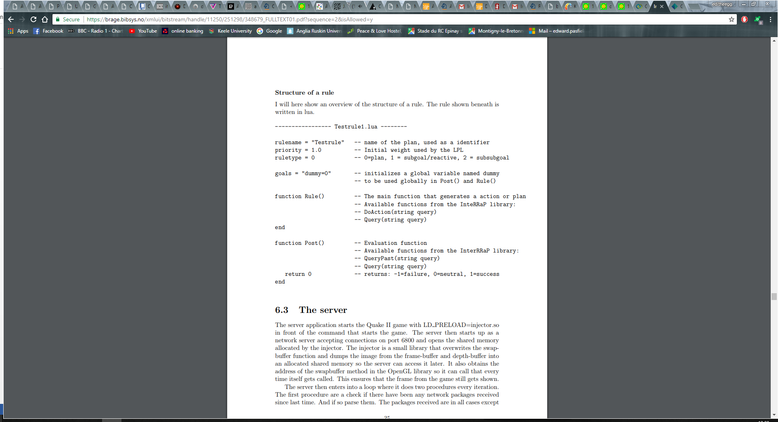

*Figure 21.*

To correctly implement this into Global Conquest the global variable used as a goal would have to be *owning all the territories*. The function Rule() would be where the heuristics would be described, such as the rule *If the benefit of the attack in troop numbers, considering ratios of troops in the territories and the troop bonus in the territory* *being attacked, is higher than any other options then execute action*. A clearly defined rule that uses logic to detect if an aggressive action is a positive one and whether to follow through with it.

The artificial intelligence approach to the agent is less work and possibly much more effective if understood and implemented correctly. Firstly, a greedy heuristic iterative algorithm would need be developed to solve the problems of a zero-sum game (Neural-network-based Zero-sum game for discrete-time nonlinear systems via iterative adaptive dynamic programming algorithm, 2018). This would be simpler than the previous option of the heuristically intelligent agent as it wouldn’t need to be as smart and would need to merely pick the first obvious best option.

The AI would be using deep reinforcement learning which incorporates both reinforcement learning (RL) and deep learning (DL). Reinforcement learning allows an agent to learn an optimal policy through trial and error based on its interactions with the environment which are incorporated as experience to accommodate for decision making (Li, 2018). Deep learning allows a computational model composed of multiple hidden layers to learn representations of data using many levels of abstraction (LeCun, 2018). An example of the use of Deep learning in the past was to increase the effectiveness of object/speech recognition. The deep network of hidden layers influences the training pattern to work its way through finding the most beneficial routes (combinations of actions) at each state. An example of a possible combination of actions in Global Conquest would the dragging of troops before and after an internal attack. The combination of DL and RL has been compared to AI as a whole and an equation was formed that summarises the effect of their combination AI = DL + RL (Silver, 2018).

The main things needed to implement this into Global Conquest would be system states, agent actions and scalar reinforcement signals.

System state - A system state is to allow for the AI to be told where it is, giving it a point of reference for learning processes. A state is defined by Silver as “the presentation of a summary of experience which in turn is a sequence of observations, actions and rewards”.

Agent actions - The agent actions are in essence the possibilities once at a state, such as a combination of external drag attacks or internal attacks.

Scalar reinforcement signals – The positive/negative feedback depending on the previous action taken to which a value is determined between 1 being the best possible and 0 the worst possible, a scale of reward as such to teach the agent what it should do next time.

An effective depiction of how the agent, environment, state and rewards all complement and work with each other is provided in a presentation given by Patrick Emami shown in figure 22.

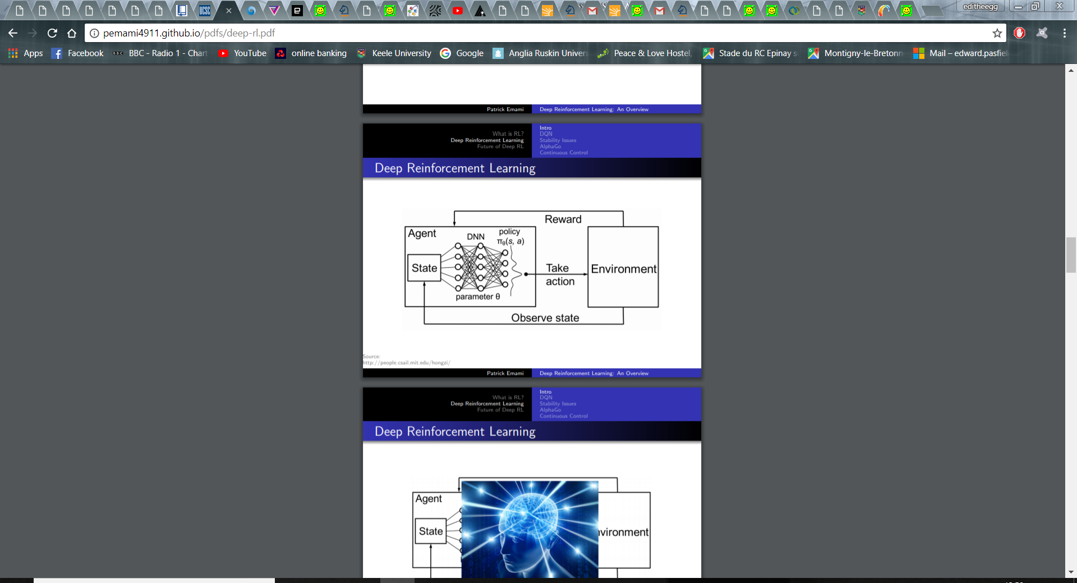

*Figure 22.*

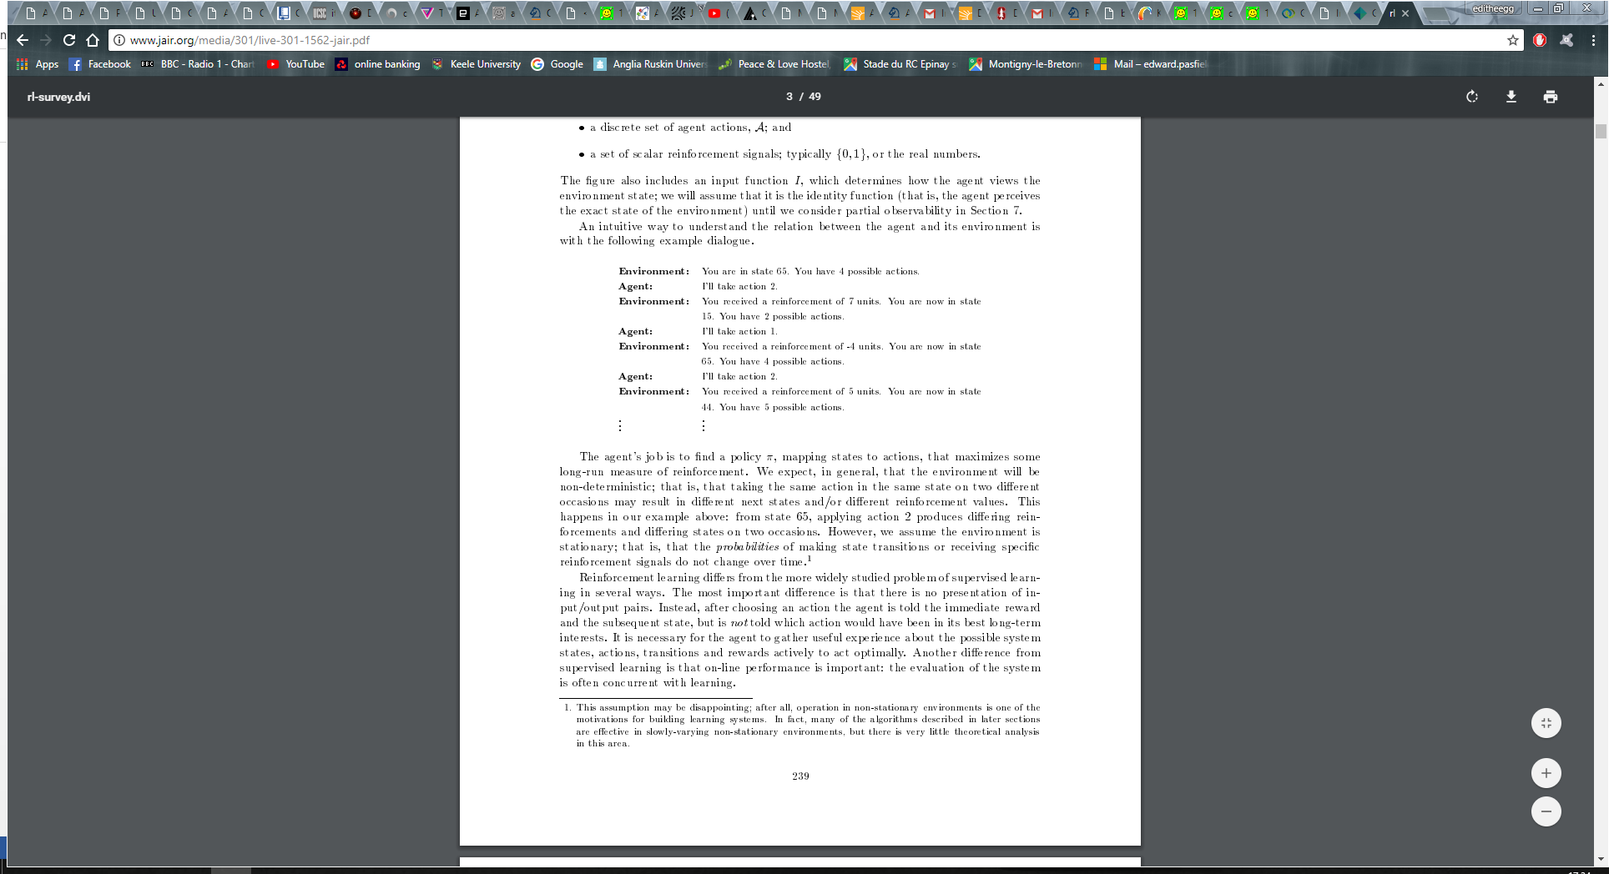After an action has been chosen the agent is then informed of the reward (calculated by the scalar reinforcement signals) and the subsequent state. The information regarding which action would have been most beneficial is incorporated as this induces the agent to accumulate experience about the possibilities the system states can get into, along with corresponding actions and rewards; the main theory behind the difference of actual artificial intelligence and heuristics. Figure 23 below (Reinforcement Learning: A Survey, 2018), is a very well worded explanation of this as it clearly identifies the possible states followed by the action and the following reward and state in a similar context to Global Conquest. A deep reinforcement learning network can also incorporate value functions which inform the system of predictions of future rewards, the ideology which breeds strategy.

*Figure 23.*

There are some inherent differences between these two techniques but the end result isn’t too different, the advantages and disadvantages of both are clearly separated in two tables below from the user’s point of view in figure 24, and the developer’s point of view figure 25.

|  |  |  |
| --- | --- | --- |
| **Agent Development Technique (Developer’s Perspective)** | **Advantages**  *Figure 24.* | **Disadvantages** |
| Heuristic Intelligent Agent | 1. Easy to understand how to implement. 2. Not dynamic, so wont overcome changes. | 1. Time consuming implementation. |
| Deep Reinforcement Learning Agent | These only occur if there is easy to use source code for the language.   1. Quick implementation. 2. More dynamic, can overcome many changes. 3. Less time consuming to implement. 4. Will use a value function to look ahead for benefits (aka form a strategy). | 1. Harder to understand and therefor maintain.   If there is no source code available.   1. More costly to implement. 2. Easy to break. |

|  |  |  |
| --- | --- | --- |
| **Agent Development Technique (Users’s Perspective)** | **Advantages**  *Figure 25.* | **Disadvantages** |
| Heuristic Intelligent Agent | 1. Won’t become unbeatable by learning and devising better strategies | 1. Won’t be as intelligent and therefor maybe not as competitive.  2. Users may get bored as they can learn how to play against a set of rules. |
| Deep Reinforcement Learning Agent | These only occur if there is easy to use source code for the language.   1. More engaging than for user to play against | 1. Will make a hard strategy for the agent to use |

The reason why there are two tables for the two different perspectives and their corresponding advantages and disadvantages is because it is important to see the difference. What may be good for the developer may not be so good for the user, and vice versa. In the context of game design the user’s perspective has to trump the developers.

To conclude, even though the DRL would have been useful due to its experience based learning and its incorporation of strategic thinking through the use of value functions what this primarily comes down to is the availability of pre made source code that can be implemented within Processing. There are open source AI’s available for Processing that are applicable in certain games/situations, unfortunately none are anything like Global Conquest. Even though these give useful insight into how AI would work within Processing this isn’t enough to make it worth attempting to implement them.

The heuristic based agent is just more appropriate for this type of game - it is easier to implement even though it might take longer (based on the developers knowledge) and wouldn’t need changing much to be able to set different levels of difficulty (a key piece of user feedback gathered during interview, see figure 15 and one of the functional requirements 5.1.1) which would be a very useful and engaging feature to add to Global Conquest.

There is however a hybrid option which, despite being the one which would take the most amount of time, would cover all bases. This option would be to implement both, using a basic heuristic agent to deliver perhaps two lower levels of difficulty, then using DRL for the top level of difficulty. This would mean that two of the aims and objectives that weren’t originally met would be - ‘two birds with one stone’. The costs of this would be more but the game would benefit greatly from it.

8.0 Conclusion

This report analyses the steps taken towards creating a simplistic zero-sum game, such as an app, and approaches this with the idea of an intelligent agent to play against. The prototyping methodology mixed with Processing to create Global Conquest will attract a group of people who are interested in creating any program using prototyping and Java to complement each other. The discussion about deep reinforcement learning (DRL) compared to a heuristically based intelligent agent a current problem, and the associated learnings will help developers determine the best way forward for their specific situations.

There was a small language barrier with the software used. When dealing with Processing due to it being so simplistic, which made it hard to use queues and more advanced data types. It also did not allow recognition of images which was the cause of the failure of the attempt to add a feature where a territory border would be highlighted when the mouse was over one. Such a graphical software shouldn’t have been used for a game of this nature, future developers should bare that in mind.

The majority of the aims and objectives for Global Conquest were fully achieved, all of which led to a prototype that was fully working and allowed people to play. The few (4, 5 and 7) that weren’t fully achieved, were partially. Objective 4 was to make the agent intelligent, adaptive and competitive. The interviews in figure 17 and others, suggest it is competitive however it isn’t adaptive, which is because it will do that same thing in any situation, randomly select attacks. As two thirds of this objective was achieved, perhaps it would have been better for this to have been three different objectives. It should have been split into “Make the agent intelligent”, “Make the agent adaptive” and “Make the agent competitive”. Aim 5 was to carry out interviews to get feedback for requirements elicitation, while intervies were not used for gathering the initial requirements, they were used to instead gather requirements to refine the protoype. Even though this did allow for new requirements to be gathered, it was not the only purpose of the interviews just a beneficial by product. What should have happened to achieve this objective is a pre-development interview for Global Conquest which would have given information from possible users about what they wanted the game to be, rather than what the developer wanted. Objective 7 was to train an artificially intelligent agent to play through the use of deep reinforcement learning. As existing source code which could be repurposed couldn’t be found the only alternative would have been to come up with brand new code for this, which was not possible given the resource and time constraints of the project.

From objective 5 there is now a selection of ideas for future developments in Global Conquest, the best few of these being animations, move prompts and new troop types (cavalry or ships). Animations is a simple idea to implement especially using Processing because of its visual arts context, which would give a better visual representation of troops and attacks if proficiently applied. This in turn would likely make the user more interested and satisfied when taking out the agent’s reinforcements. Move prompts is another idea which programmatically would be deemed easy, a use of delays to print an appropriate message to the screen, for example notifying the user of the phase they are in, and/or what attacks/territories they can attack/allocate troops to. To deliver these would cause significantly higher complexity within the program mainly because a new object ‘Troop’ would have to be created, an idea taken into account when encapsulating the code originally (mentioned in 1.1). The Troop object would be defined and would have different strengths and different rights, for example Troop type Ship may have the right to be in the sea (not on land) and only attack territories adjacent to the sea, whereas Troop type Cavalry could be a stronger troop that could have the right to go through a continent to attack any adjacent territories - a complicated set of requirements for these Troops would have to be defined. Additionally this future design possibility would also have to take into account the agent either being a heuristically based agent or designed with DRL. If heuristically based, then a lot of extra code would need to be developed to implement all the different possibilities, whereas a DRL based agent would likely overcome these new troop possibilities with ease as it would learn how to use them to its benefit.

The overall conclusion drawn from is that the intelligent heuristic agent is more appropriate for a project with very limited time and resource constraints to develop a simple game as rules were easier to follow, and although technically there would be more code to apply it would be simpler. A significant learning which also came from the project is the previously unidentified option to use both approaches, which only became apparent after the creation of the heuristically intelligent agent as it could be used to assist in the creation of the AI agent.

# 9.0 Appendices

## 9.1 Appendix A – User Guide

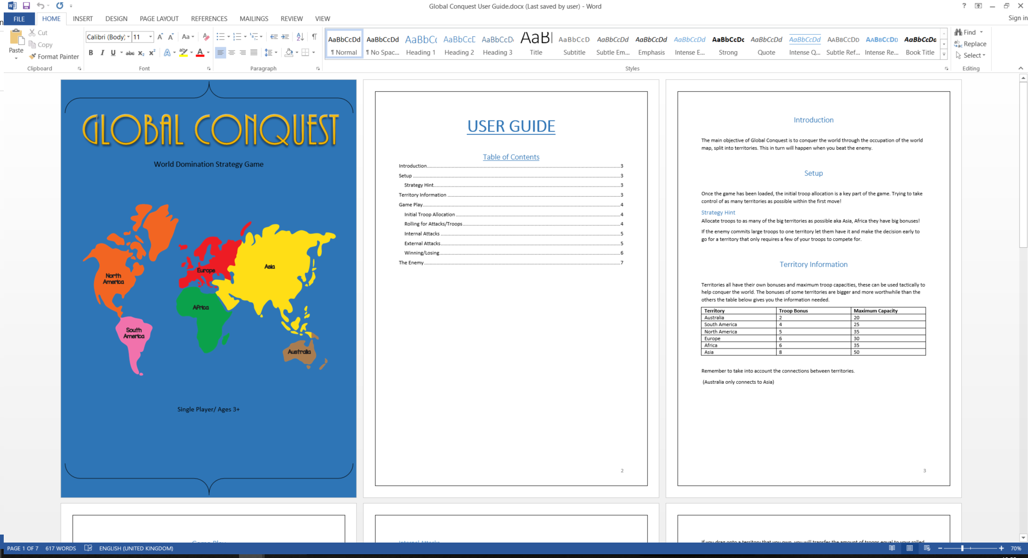

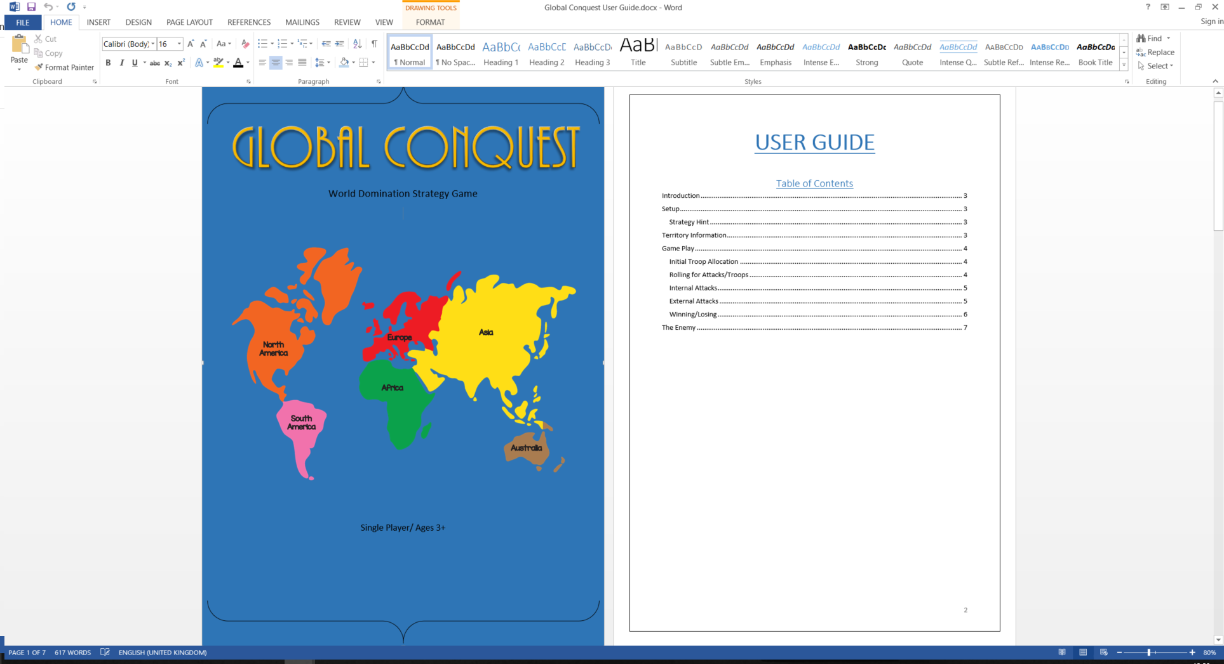

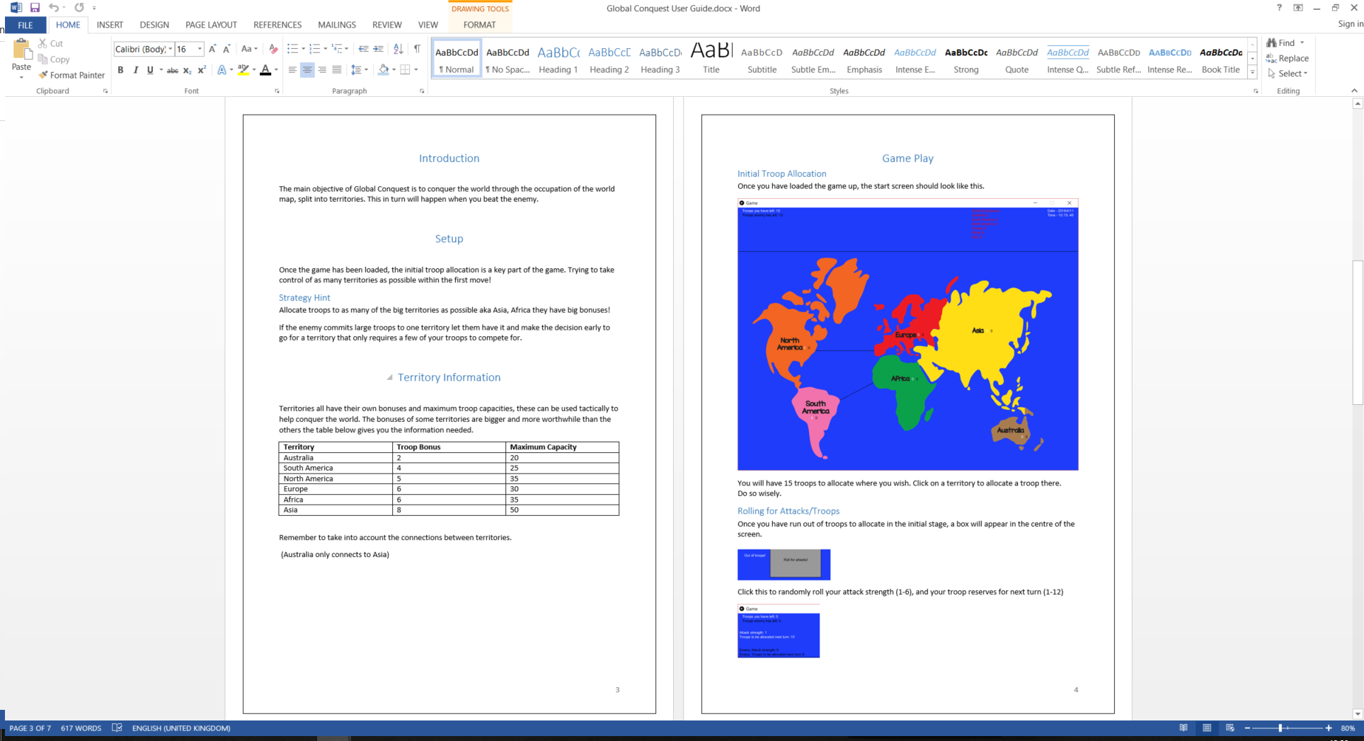



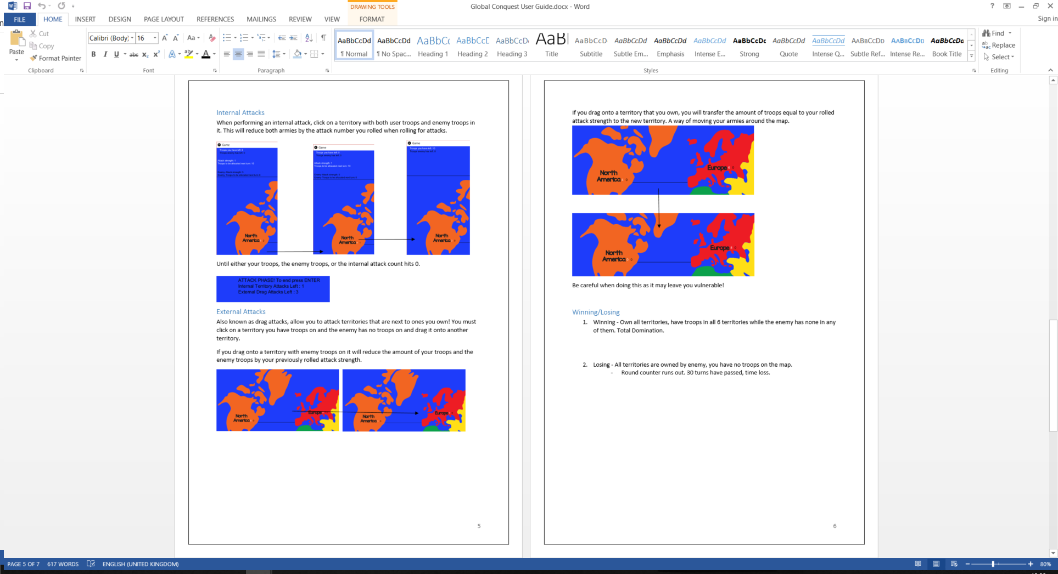



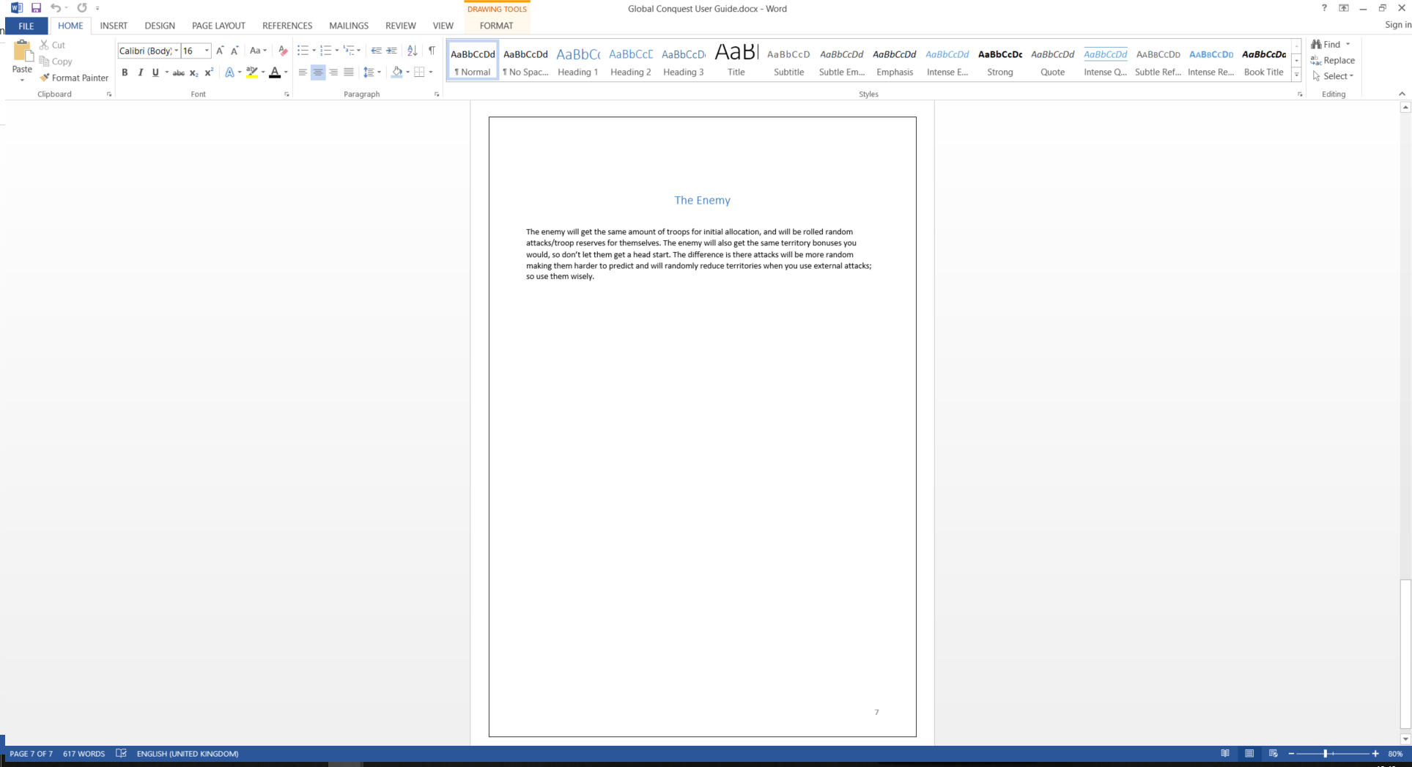

## 9.2 Appendix B – Global Conquest Code

## 9.2.1 – Click Attack

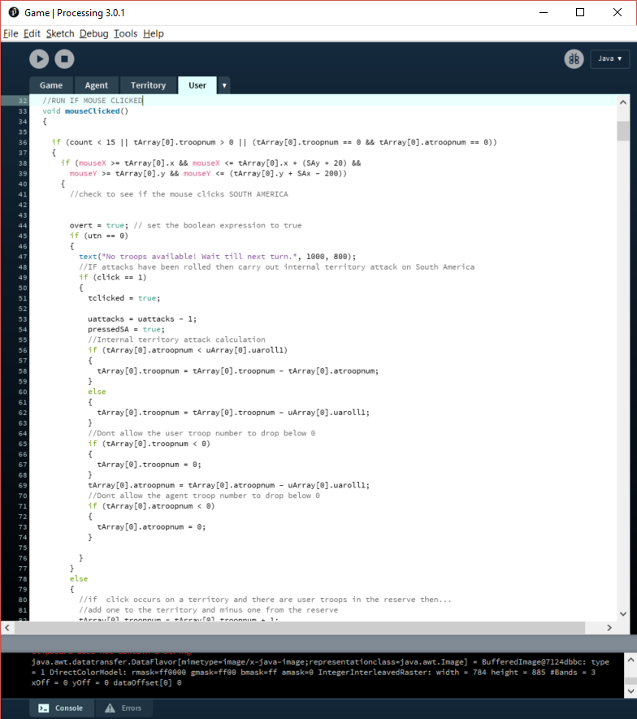

## 9.2.2 – Territory Capacities

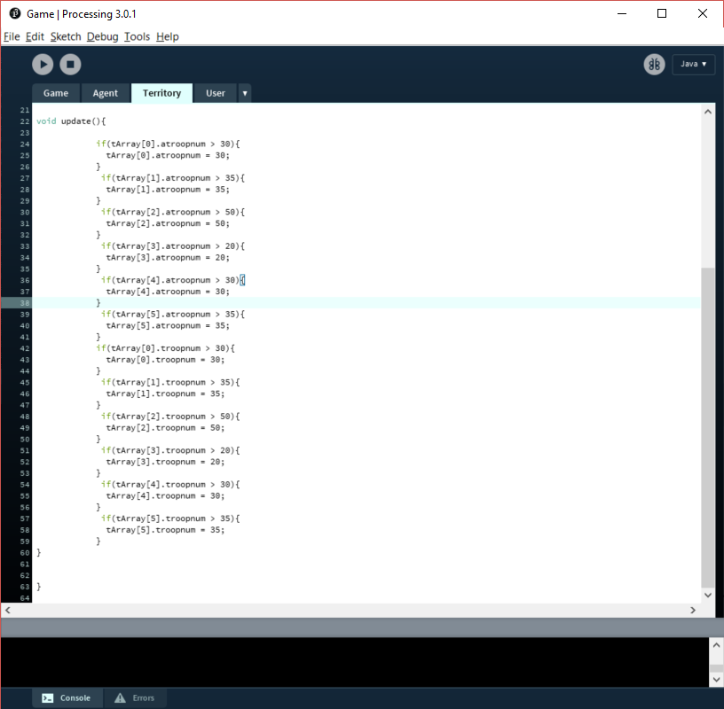

## 9.2.3 – Troop Bonuses

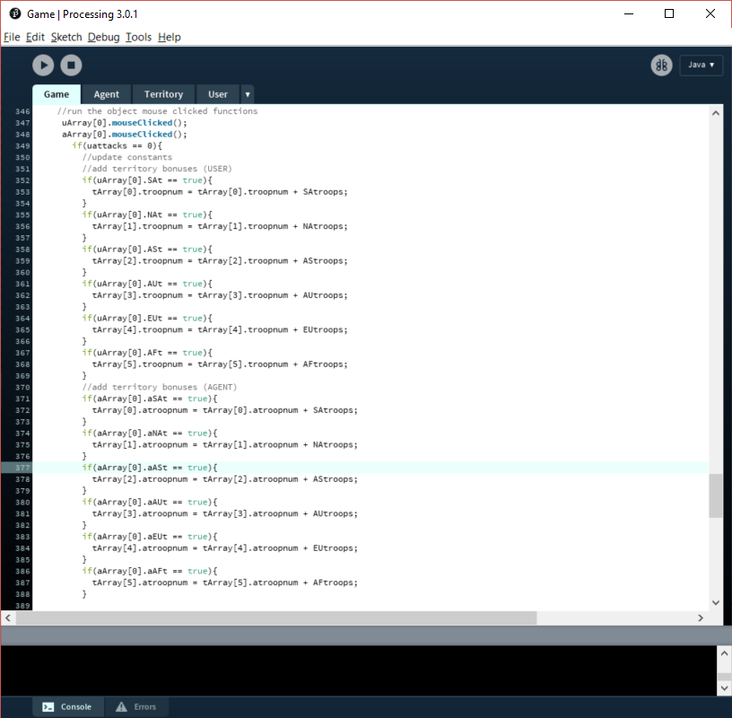



# 10.0 Bibliography

Agent Technologoy. (2018). [ebook] Berlin, pp.3-28. Available at: <https://link.springer.com/chapter/10.1007/978-3-662-03678-5_1> [Accessed 12 Apr. 2018].

Anon, (2018). [online] Available at: <http://istqbexamcertification.com/what-is-prototype-model-advantages-disadvantages-and-when-to-use-it/> [Accessed 4Feb. 2018]

Anon, (2018). Should games have a fixed difficulty mode?. [online] Available at: <https://www.gamespot.com/forums/system-wars-314259282/should-games-have-a-fixed-difficulty-mode-33362793/> [Accessed 15 Apr. 2018]

Burgen, K. (2013) Game design theory: a new philosophy for understanding games. (CRC Press, US)

Cs.cmu.edu. (2018). Agent Intelligence. [online] Available at: <http://www.cs.cmu.edu/~lanthony/classes/SEng/Design/heuristic.html> [Accessed 7 Apr. 2018]

Deep Learning NN. (2018). [image] Available at: <https://www.quora.com/What-is-the-difference-between-Neural-Networks-and-Deep-Learning> [Accessed 13 Apr. 2018].

Fidas, C. (2018). Requirements Elicitation for new Video Game Development Tools: A Case Study. [ebook] pp 1-3. Available at: <http://hci.ece.upatras.gr/files/c201_Fidas_Avouris_Orvieto_Interact_2015.pdf> [Accessed 10 Apr. 2018]

Fingas, J. (2018). AI beats top ‘Dota 2’ players in one-on-one matches. *Engadget.* [online] Available at: <https://www.engadget.com/2017/08/12/ai-beats-top-dota-2-players/> [Accessed 15 Apr. 2018].

LeCun, Y. (2018). Deep Learning. [ebook] Available at: <https://www.nature.com/articles/nature14539> [Accessed 15 Apr. 2018].

Li, Y. (2018). Deep Reinforcement Learning: An Overview. [ebook] Available at: <https://arxiv.org/pdf/1701.07274.pdf> [Accessed 14 Apr. 2018].

LØLAND, K. (2018). Intelligent Agents in Computer Games. [ebook] Norwegian University of Science and Technology. Available at: <https://brage.bibsys.no/xmlui/bitstream/handle/11250/251298/348679_FULLTEXT01.pdf?sequence=2&isAllowed=y> [Accessed 14 Apr. 2018]

Masters, M. (2018). An Overview of Requirements Elicitation > Business Analyst Community & Resources | Modern Analyst. [online] Mondernanalyst.com. Available at: <http://www.modernanalyst.com/Resources/Articles/tabid/115/ID/1427/An-Overview-of-Requirements-Elicitation.aspx> [Accessed 10 Apr. 2018].

Mnih, V. (2018). *Playing Atari with Deep Reinforcement Learning.* [ebook] Available at: <https://arxiv.org/pdf/1312.5602.pdf> [Accessed 11 Apr. 2018].

Neural-network-based Zero-sum game for discrete-time nonlinear systems via iteratie adaptive dynamic programming algorithm. (2018). [ebook] Institue of Automation, Chinese Academy of Sciences, Beijing 100190, PR China. Available at: <https://www.sciencedirect.com/science/article/pii/S0925231213000076> [Accessed 14 Apr. 2018]

Ozcan, E. (2018). *A Simple Intelligent Agent for Playing abalone Game: ABLA.* [pdf] Istanbul: Yeditepe University. Available at: <https://pdfs.semanticscholar.org/91d2/51c2532316fc1f70c146c022a2cb5c3ab0cc.pdf> [Accessed 11. Apr. 2018]

Pasfield, E. (2018). An AI Approach to a World Domination Game.

Processing.org. (2018). Processing.org. [online] Available at: <https://processing.org/> [Accessed 8 Apr. 2018].

Prototyping Model. (2018). [image] Available at: <http://istqbexamcertification.com/what-is-prototype-model-advantages-disadvantages-and-when-to-use-it/> [Accessed 4 Feb. 2018].

Reinforcement Learning: A Survey. (2018). [ebook] Brown University. Available at: <http://www.jair.org/media/301/live-301-1562-jair.pdf> [Accessed 14 Apr. 2018]

Silver, D. (2016). Deep reinforcement learning, a tutorial at ICML 2016. http://icml.cc/ 2016/tutorials/deep_rl_tutorial.pdf.

Space Invaders Atari 2600. (2018). [image] Available at: <https://www.giantbomb.com/space-invaders/3030-5099/> [Accessed 13 Apr. 2018]

Stefik, M. (2018). Object Oriented Programming: Themes and Variations. [ebook] p.41. Available at: <https://www.aaai.org/ojs/index.php/aimmagazine/article/view/508/444> [Accessed 10 Apr. 2018].

World Map – Continents. (2018). [image] Available at: <https://www.giftofcuriosity.com/product/montessori-world-map-and-continents-printables/> [Accessed 6 Jan. 2018].